G40 Portable Gas Detection and Alarm Instrument

G40

Operating Instructions

Henan Otywell Electronic Technology Co., Ltd.
ISO9001 Quality Management System Certified Enterprise

Thank you for using the product series of Henan Otywell Electronic Technology Co., Ltd. Please read this manual carefully before using the product and follow the relevant operating procedures provided. This will allow you to fully enjoy the services we offer and avoid damage to the device or other accidents caused by incorrect operation.

Please keep this manual properly for easy reference and assistance whenever you need it in the future.

Copyright Statement
This manual is the exclusive property of Henan Otywell Electronic Technology Co., Ltd. Without written permission, no part of this manual may be reproduced, translated, stored in any database or retrieval system, nor disseminated by any means including electronic transmission, photocopying, audio recording, etc.
Henan Otywell Electronic Technology Co., Ltd. adheres to the principle of technological advancement and is committed to continuous product improvement and performance enhancement. The company reserves the right to make any product improvements without prior notice.
If the user installs, repairs or replaces components without following the instructions in this manual, the resulting liabilities shall be borne solely by the user.
The actual product, including its color and style, shall prevail over all representations.
User Service Guide
1. Before using this product, carefully check whether the accessories, product certification and user warranty card are complete in accordance with the factory delivery list. If any item is missing, contact the seller or manufacturer immediately.
- Within twelve months from the date of sale, free repair services will be provided upon presentation of the warranty card if the product quality fails to meet the technical specifications under the condition that the user complies with the specified storage, transportation and usage requirements.
- The company will charge for repair services in case of damage caused by violation of operating regulations, malfunctions arising from repairs by non-designated authorized technical service departments, or product quality problems caused by force majeure factors.

- After product maintenance or repair, the maintenance personnel shall fill in and sign the Maintenance and Repair Record; you are also required to sign and confirm on the Maintenance and Repair Record provided by the maintenance personnel.
- If you have any questions or comments about the products and services we provide, please contact us in a timely manner. We will handle your feedback appropriately.

The product appearance and colors shown in the product catalog are for reference only, and the actual supply shall be subject to the physical products. The company reserves the right to modify the technical parameters of the relevant products in this catalog without prior notice. For inquiries, please call our company's service hotline.

Table of Contents

1 、Overview 5
1
2 、OverallProductStructureDiagram 8
3
3 、ProductFunctionsandOperation 8
3
4 、AlarmInformation 15
9
5 、ChargingFunctionDescription 16
10
6 、PrecautionsforUse 16
11
7 、CommonFaultsandSolutions 17
12
8 、Storage 18
12
9 、Accessories 18
12

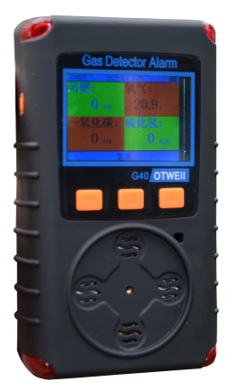
I. 1. Overview

This multi-combination gas detection and alarm instrument is an intrinsically safe device capable of continuously detecting the concentration of leaking gas. The instrument adopts embedded microcomputer control, featuring simple operation and comprehensive functions.

The housing of this multi-combination gas detection and alarm instrument is made of high-strength engineering plastic with a silicone protective sleeve, boasting high structural strength, a comfortable grip, and waterproof, dustproof and explosion-proof performance.

This multi-combination gas detection and alarm instrument can detect 5 types of gases simultaneously, with the 5 gas types available for arbitrary combination.

1.1 National Standards Complied with in the Design, Manufacturing and Verification of This Product

GB/T 3836.1—2021 Explosive Atmospheres - Part 1: Equipment - General Requirements

GB/T 3836.4—2021 Explosive Atmospheres - Part 4: Equipment Protected by Intrinsically Safe Type 'i' ProtectionGB 12358—2024 Environmental Gas Detection and Alarm Instruments for Workplace - General Technical RequirementsGB/T 4208—2017 Enclosure Protection Rating (IP Code)

1.2 Model Description
The meanings of the detector's model and code are as follows:
G 40

Design Serial Number

Product Type

For model G40, G stands for the product type (indicating a gas detection and alarm instrument), and 40 represents the design serial number (indicating a multi-combination type).
1.3 Gas Units and Conversion Relationships

(1) ppm: Refers to one part per million of the gas volume percentage content. For example, 5 ppm carbon monoxide means the air contains 5 parts per million of carbon monoxide.
(2) LEL: Refers to the lower explosive limit concentration of a gas. The minimum concentration of a flammable gas in air that can ignite when exposed to an open flame is called the lower explosive limit, abbreviated as %LEL (English: Lower Explosion Limit). For instance, 10% LEL means the concentration reaches 10% of the gas's lower explosive limit. When the concentration of a flammable gas in air reaches its lower explosive limit, the explosion hazard level of the flammable gas environment at this location is deemed 100%, i.e., 100% LEL.
(3) %VOL: Refers to the gas volume percentage. For example, 5%VOL means a specific gas accounts for 5% of the total volume in the air.
(4) µmol/mol: Micromoles per mole, a unit of the amount of substance.

- Interrelationship: VOL is the largest in order of magnitude among the three units (ppm, LEL, VOL).

Example: The lower explosive limit of methane is 5%VOL, so methane gas at 10%LEL corresponds to the following relationship:
10%LEL = 0.5%VOL = 5000ppm = 5000×10⁻⁶ = 5000µmol/mol

1.4 Technical Parameters
- Suitable gases: combustible/toxic/hazardous gases/oxygen, etc.
- Detection principles: catalytic combustion type, electrochemical type, infrared type, laser type, semiconductor type, etc.
- Detection method: Free diffusion type
- Measurement range: (0–100)%LEL (flammable); (0–100)µmol/mol (toxic), etc. (multiple ranges available)
- Resolution: 1% LEL, 1 ppm, 0.1 ppm/%VOL
- Accuracy grade: ±3%FS (flammable); ±5 µmol/mol or ±10% (toxic) (depending on the specific gas)
- Lower limit alarm setting: 20% LEL (flammable)
- Upper limit alarm setpoint: 50% LEL (flammable)
- Display method: LCD
- Response time: ≤30s (flammable) (depending on the specific gas)
- Environmental temperature: -25°C to +55°C
- Relative humidity: (20～93)%
- Operating voltage: DC 3.7 V
- Battery capacity: 2000 mAh lithium-ion rechargeable battery
- Charging time: 6h to 8h
- Working hours: ≥8 h (continuous)
- Pressure limit: 86 kPa to 106 kPa
- External dimensions: L 122 mm × W 68 mm × H 33 mm
- Product weight: approximately 210 g
- Explosion-proof certificate number: CLEx24.1023
- Explosion-proof rating: Ex ia ⅡC T4 Ga; Ex ib ⅢC T130℃ Db
- Protection rating: IP65

II. Overall Product Structure Diagram

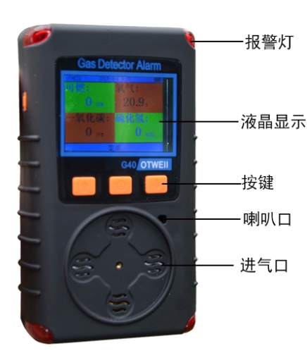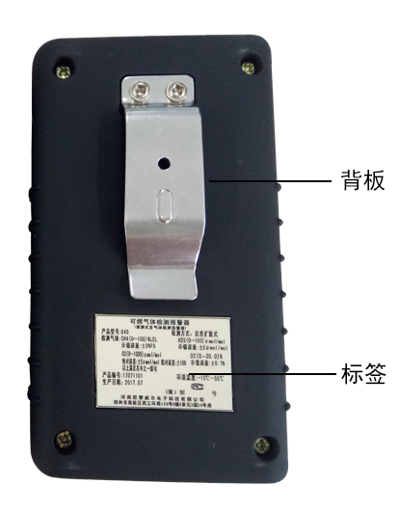
Note: This product employs natural diffusion detection. The included calibration hood is only for installation or covering during product calibration and must be removed during normal detection to prevent detection failure and potential personal injury!

III. Product Features and Operation
3.1 Product Display Interface Description

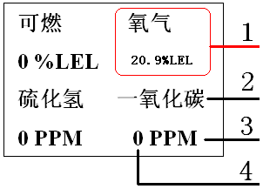

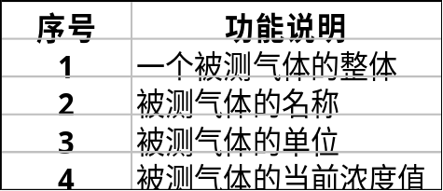
3.2 Key Function Description

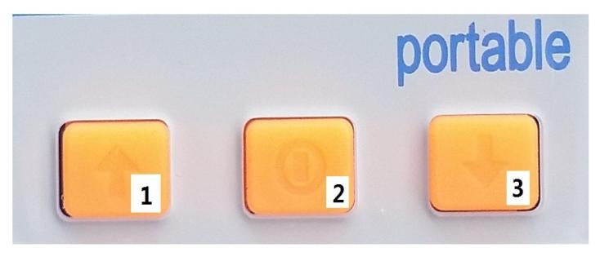

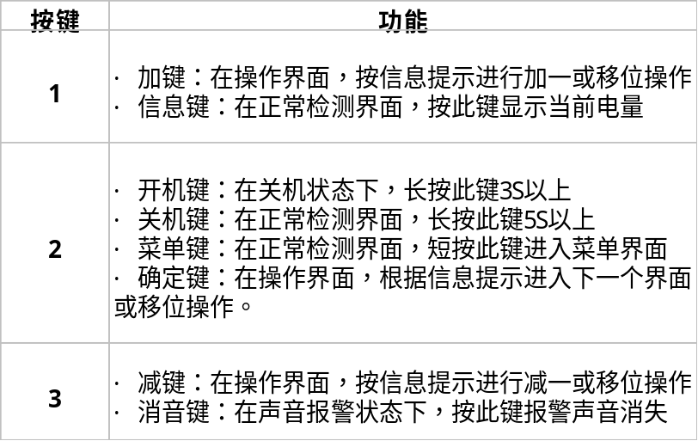
3.3 Product Startup Instructions
When the detector is powered off, press the "" key for approximately 5 seconds. A prolonged "beep" sound will be heard, followed by the backlight on the display screen turning on. The detector then transitions from shutdown to startup mode, displaying a welcome interface and initiating a self-check. During this process, the detector automatically activates audible, visual, and vibration alarms. Users can verify the detector's operational integrity based on these indicators.
Welcome to the version display interface and startup interface:
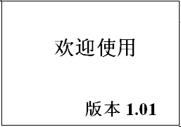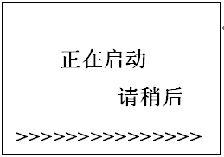
Self-check interface:
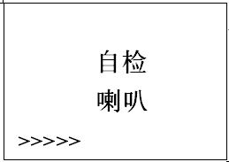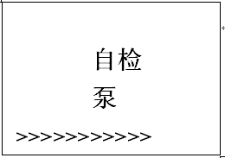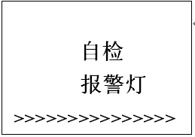
Information preview interface:
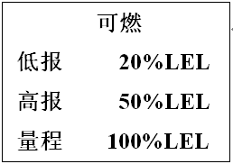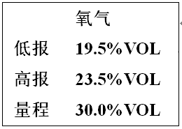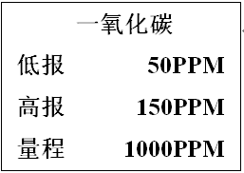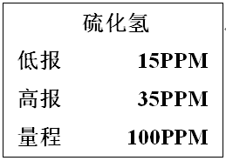
Normal monitoring interface:
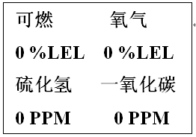

3.4 Product Shutdown Instructions
When the detector is in normal detection mode, holding the "" key for more than approximately 5 seconds will trigger continuous "beep" sounds from the buzzer, followed by screen shutdown. The detector then enters a power-off state with no information displayed on the screen.

3.5 Product Menu Operation Instructions
See the table below for user menu function descriptions:
menu | function declaration
Alarm record | View alarm status for each gas
Underreporting Settings | Adjust the primary alarm threshold for each gas type
High reporting settings | Adjust the secondary alarm threshold for each gas type
Zero point setting | When the value in clean air is not zero, reset to zero.
Calibration settings | For calibration when there is an error between measured gas values and actual values
Time settings | Calibrate the time to match the actual time
Backlight settings | Adjust backlight to always on or automatic
Password settings | Change the default password to a private password
self-checking | Check whether each component functions properly
Channel information | Preview information such as low reading, high reading, and range for the measured gas
Exit menu | Back to the monitoring interface

See the table below for specific product menu operations:
Display screen parameters | Detailed feature introduction
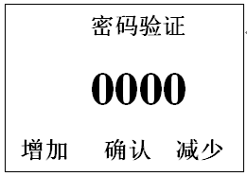graph 1  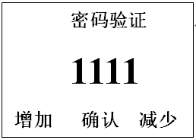graph 2 | Go to menu settings:  Under normal detection mode, the detector enters the password verification interface by pressing keys (as shown in Figure 1). Pressing keys increases or decreases the numerical value, while key shifting adjusts the interface to the configuration shown in Figure 2. Subsequent key presses then access the menu settings interface.
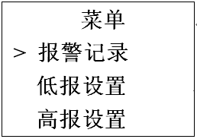graph 3  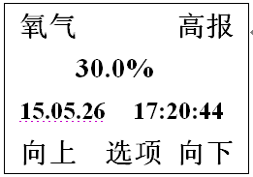graph 4 | 1. Alarm records  Under the menu function settings, press or select Alarm Records as shown in Figure 3; press the button to enter the Alarm Record View interface as shown in Figure 4; press the button to view Alarm Records by scrolling up or down. After pressing the button to enter the next interface, follow the prompts to exit or delete the Alarm Records.
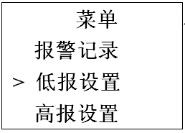graph 5  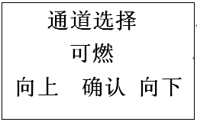graph 6  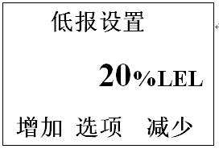graph 7 | 2. Underreporting Settings  To access the menu settings, press or select the underreporting settings as shown in Figure 5. Press the button to enter the channel selection interface (Figure 6). Press or select 'flammable,' 'oxygen,' or 'other' to proceed to the next interface (Figure 7). Press to adjust data values upward or downward. After entering the next interface, follow the prompts to save settings or exit directly.  Do not modify alarm threshold parameters unless specified otherwise.
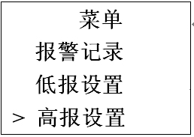graph 8  graph 9  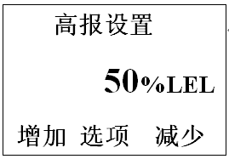graph 10 | 3. High reporting settings  To access the menu settings, press or select the high reporting settings as shown in Figure 8. Press the button to enter the channel selection interface (Figure 9). Press or select combustible, oxygen, or other options to proceed to the next interface (Figure 10). Press to adjust data values upward or downward. After entering the next interface, follow the prompts to save settings or exit directly.  Do not modify alarm threshold parameters unless specified otherwise.
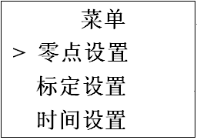graph 11  graph 12  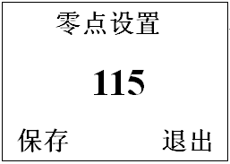graph 13 | 4. Zero Point Setting  Access the menu settings and select Zero Point Settings (Figure 11). Press the button to enter the password verification interface (to prevent accidental operations). After password verification, proceed to the channel selection interface (Figure 12). Press or select combustible, oxygen, or other options to proceed to the next interface (Figure 13). Press Save or Exit to complete the process.
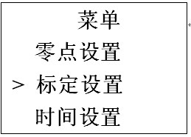graph 14 | 5. Calibration Settings  For assistance, contact the manufacturer.
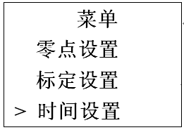graph 15  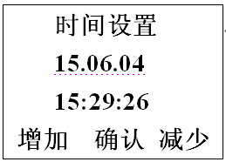graph 16 | 6. Time settings  Access the menu settings function, then press or select Time Settings as shown in Figure 15. Press the button to enter the Time Settings interface (Figure 16). Press to adjust data values (increase or decrease), or use the shift key for navigation. After completing the settings, press to proceed to the next interface and select Save or exit directly.
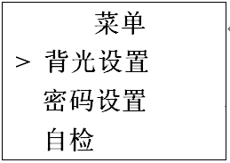graph 17  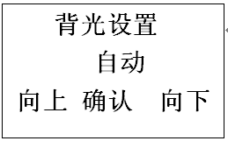graph 18 | 7. Backlight settings  Access the menu settings function, then press or select backlight settings as shown in Figure 17; press the button to enter the backlight settings interface as shown in Figure 18; select automatic or constant mode; finally press save data.
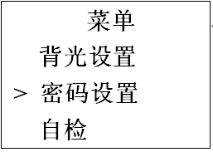graph 19 | 8. Password settings  Go to the menu settings function, press or select password settings as shown in Figure 19; press the button to enter the password verification interface; after password verification, you can input a new four-digit password; then press the button to enter the save confirmation interface.  Unless under special circumstances, do not change your password.
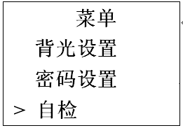  graph 20  graph 21  graph 22  graph 23 | 9. Self-examination  Access the menu settings and select or press the self-check function as shown in Figure 20. Press the button to enter the self-check interface. When entering the interface shown in Figure 21, check whether the speaker emits intermittent sounds. In Figure 22, verify if the pump can operate normally with on/off functionality. For Figure 23, inspect whether the alarm light functions properly with normal illumination and extinction cycles.
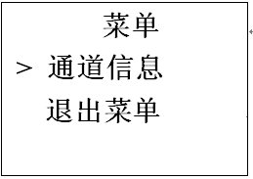graph 24  graph 25  graph 26  graph 27  graph 28 | 10. Channel Information  Under the menu function settings, press or select channel information as shown in Figure 24; press the button to enter the channel information display interface; the low reading, high reading, and range values of each channel are displayed, as shown in Figures 25,26,27, and 28.
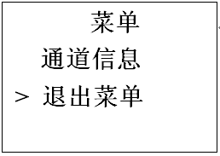graph 29 | 11. Exit menu  Enter the menu function settings, press or select to exit the menu as shown in Figure 29; the button returns to the normal detection interface.

IV. Alarm Information
The table below shows the information displayed for each alarm:
Alert type | Display information
Low alarm:  Slow pitch modulation of the alarm sound  The red alarm lights in both groups flashed.  vibrate | 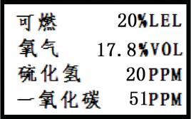
High alarm:  Abnormal rapid pitch-changing alarm sound  The alarm lights in both groups flashed.  vibrate | 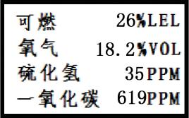
Sensor protection and fault:  Sudden pitch-shifted alarm sound  In the absence of gas, the concentration display indicates 100% Lower Explosive Limit (LEL).  The alarm light remains continuously flashing in the absence of gas. | 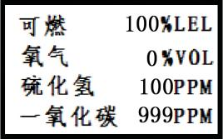

V. Charging Function Description
When the device displays low battery level or fails to power on due to undervoltage, perform charging immediately: With the detector powered off, connect the charger's plug to its charging port and attach the AC connector to a 220V power supply. The detector will automatically activate, displaying charging status. Once the battery icon on the screen stabilizes at full capacity, charging is complete. At this point, unplug the charger and the detector will resume normal operation.
charge  - After the friendly interface ends, it displays "Charging in progress!!!" with a welcome message.  - blinking red lamp  - The battery is fully charged after charging. | 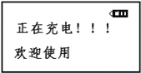
undervoltage  - Alarm sound notification  - The interface displays "Please charge" and asks you to charge promptly in a safe location. Otherwise, the device will shut down automatically. | 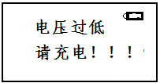
Warning: Charging the detector while powered off prevents its activation for testing. Do not charge the detector at the testing site to avoid fire or explosion caused by sparks from unplugging the charger. Additionally, avoid charging the detector while powered on to prevent interference with charging speed.

VI. Precautions for Use
(1) Prevent the device from falling from a height or experiencing severe vibration.
(2) The device may not function properly in the presence of high-concentration gases.
(3) Please strictly follow the instructions for operation and use; otherwise, it may lead to inaccurate test results or damage to the device.
(4) This product shall not be stored or used in environments containing corrosive gases (such as high concentrations of chlorine gas), nor shall it be used or stored under other harsh conditions (including extreme temperatures, high humidity, electromagnetic fields, or intense sunlight).
(5) If the surface of this device becomes contaminated after prolonged use, gently wipe it with a clean soft cloth dampened with water. Avoid using corrosive solvents or hard objects for cleaning, as this may cause scratches or damage to the device surface.
(6) To ensure detection accuracy, this device shall undergo periodic calibration, with the verification cycle not exceeding one year.
(7) It is recommended that infrared sensors and semiconductor sensors have a service life of 5 years, while catalytic combustion sensors and electrochemical sensors have a service life of 2 years.
(8) Please remove the lithium battery and sensors from the discarded detector and deliver them to the designated location or return them to our company. Do not dispose of them in trash bins indiscriminately.
(9) For any applications or usage issues beyond those described in this manual, please contact our company for assistance.
(10) Battery packs must not be disassembled or replaced, nor charged in explosive gas environments. Peripheral plug-in devices without explosion-proof certification must not be used, and sensors must not be replaced in such environments.
(11) Products with explosion-proof certification shall not be arbitrarily replaced or modified with components or structures that affect their explosion-proof performance.
(12) Relevant national standards contain explicit regulations on the selection, installation, or use of electrical equipment in explosion-hazardous environments. Installation or user entities must strictly comply with these provisions to ensure explosion-proof safety of electrical equipment in such areas.
(13) Charging must be performed in a safe location and using the professional charger provided with this device.

VII. Common Faults and Their Solutions
fault phenomenon | Possible cause of failure | process mode
Cannot boot | voltage below level | Charge your device promptly
Cannot boot | system halted | Contact the dealer or manufacturer for repair
Cannot boot | fault | Contact the dealer or manufacturer for repair
No reaction to the detected gas | Circuit failure or sensor lifespan expired | Contact the dealer or manufacturer for repair
Display is inaccurate | Sensor expired | Contact the dealer or manufacturer for repair
Display is inaccurate | Long-term uncalibrated | Calibrate promptly
Time display error | The battery is completely drained | Charge promptly and reset the time
Time display error | strong electromagnetic interference | Reset time
Zero calibration is unavailable | Excessive sensor drift | Calibrate or replace the sensor promptly
Display non-zero values in clean air environments | Sensor drift | Perform zero calibration
The instrument's normal detection interface displays full range indication | Sensor failure | Contact the dealer or manufacturer to replace the sensor.

VIII. Storage
The product shall be stored in a ventilated room with an ambient temperature ranging from-10°C to +55°C and relative humidity not exceeding 85%, and the air must be free from harmful gases or impurities that may cause corrosion to the product.

IX. Accessories
The accompanying products include one portable gas detection alarm device, one user manual, one product qualification certificate and warranty card, one factory inspection report, and one set of chargers.

Henan Otywell Electronic Technology Co., Ltd.
Address: Unit 2, Building 38, Lian Dong U Valley, intersection of Jianyang Road and Lianhua Street, High-tech Zone, Zhengzhou City, Henan Province
Hotline: 400-811-8873
Website: http://www.otywell.com





Zhihui Cloud WeChat Mini Program
Zhihui Cloud APP installation package
WeChat Official Account

