Open-circuit Laser Gas Telemetry Instrument

G6000B

operating instruction

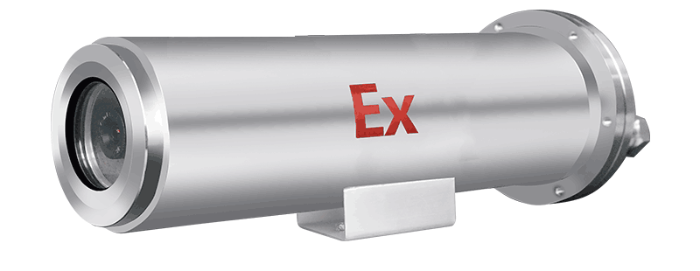

Henan Otywell Electronic Technology Co., Ltd.

catalogue
I. Essential Reading for Users 1 4
1.1 User Guidelines 1 4
1.2 Quality Assurance and Exemption Clauses 1 4
1.3 Standards followed by this product 2 5
1.4 Safety Precautions 2 5
1.4.1 Precautions for Safe Operation of Instruments 2 5
1.4.2 Other Safety Precautions 2 5
1.5 Avoid using faulty 3 6
II. Product Introduction 4 6
2.1 Product Overview 4 6
2.1.1 Detection Principle 4 7
2.2 Transceiver Device 4 7
2.3 Receiving Device 4 7
III. Operational Procedures 5 8
3.1 Equipment Inspection 5 8
3.2 Equipment Operation 5 8
IV. Installation Operating Procedures 5 8
4.1 Installation Environment Requirements 5 8
4.2 Installation Location Requirements 6 8
4.3 Installation Dimensions and Requirements 6 9
4.3.1 Appearance and Installation Dimension Diagram 6 9
4.3.2 Installation Requirements 6 9
4.4 Installation Procedures and Testing Methods 8 11
4.5 Interface and Connector Installation Requirements 9 12
4.6 Installation Precautions 9 12
V. Factors Affecting Accuracy 10 13
VI. Troubleshooting Common Issues 10 13
VII. Appendix 11 14
7.1 Daily Maintenance and Care 11 14
7.2 Performance Parameter Table 11 14

1. Essential Reading for Users
This instrument has been calibrated prior to shipment.

1.1 User Guidelines
Welcome to the G6000B open-circuit laser gas telemetry system (hereinafter referred to as the Telemetry System). Before using this product, please carefully read this manual. It contains essential operational information and technical specifications that users must strictly follow to ensure proper system operation. The provided guidance will also assist users in correctly operating the device and obtaining accurate analytical results.
This manual provides comprehensive guidance on the proper use of telemetry instruments. It serves as an accurate reference for technicians who have received professional training or possess relevant knowledge in instrument operation and control. Before operating the instruments, ensure you fully understand the safety instructions and warnings outlined in this manual and apply them during practical operations. Due to various limitations, this manual cannot provide detailed descriptions for every scenario. If users require further information or need assistance with issues not covered herein, please contact Henan Outewell Electronic Technology Co., Ltd. at 400-811-8873 for support.

1.2 Quality Assurance and Exemption Clauses
By choosing Outeiwei, you are selecting high-quality products. All products from our company are eligible for free repairs during the warranty period; after the warranty period, corresponding component replacement fees will be charged. If you encounter any issues during use, please contact us for prompt assistance. The entire instrument is covered by a one-year warranty.
Any repairs beyond the warranty period or those occurring during the warranty period that involve the following faults shall be considered out-of-warranty repairs, for which no free warranty service will be provided. Outeiwell reserves the right to charge any on-site maintenance fees. These faults include, but are not limited to:
1) Due to improper use (internal water ingress, corrosion, fire, or electrical interference from high-voltage circuits);
2) Force majeure (damage caused by earthquakes, lightning strikes, floods, etc.);
3) Unauthorized modification of product internals without permission;
4) Failure to use the product in accordance with the user manual and training regulations, resulting in product damage;
This manual only covers instruments and components sold to buyers by authorized suppliers, distributors, and representatives of Otover.

1.3 Standards followed by this product
GB 3836.1-2010 Explosive Atmospheres Part 1: Equipment General Requirements
GB 3836.2-2010 Explosive Atmospheres Part 2: Equipment protected by flameproof enclosure'd'
IEC60079-28:2006 Explosive environments Part 28: Protective measures for optical radiation equipment and transmission systems

1.4 Safety Precautions
Before using this instrument, please ensure that you have read and understood the safety precautions described below.

1.4.1 Precautions for Safe Operation of Instruments
warn ：
1. The instrument must be protected from radiation of high-temperature heat sources, as excessively high or low temperatures may adversely affect the performance and lifespan of the sensor.
2. Avoid prolonged staring at the laser emitter to prevent eye burns.
3. The instrument has a metal casing. Do not touch it when powered on to avoid electric shock.

1.4.2 Other Safety Precautions
1) This instrument is classified as precision equipment. Do not attempt to disassemble, modify, or alter the device. If the instrument fails to operate normally or exhibits malfunctions, please contact us.
2) If the instrument is accidentally damaged, immediately cease operation, shut down the device after confirming environmental safety, disconnect the power supply, and contact us.
3) Do not use benzene, diluents, or gaseous solvents to clean the instrument housing or lenses;
4) Output method: For 4-20mA outputs connected to safety zones, a safety barrier must be added to prevent external energy input before connecting to other devices; however, this is not required when connecting to intrinsically safe equipment.

1.5 Avoid using faulty equipment
To minimize the risk of failures, read the following carefully.
When using the instrument during humid weather conditions such as rain or snow, or during hazy weather with high dust concentrations, the following precautions should be observed:
This instrument is designed to prevent vertically falling water droplets from entering its interior. For humid weather conditions such as rain or snow, as well as smoggy environments with high dust concentrations, the following precautions and specific solutions should be noted:
1) The glass lenses of the product's receiving and transmitting device are prone to water droplet adhesion during humid weather conditions such as rain or snow, which may interfere with signal reception and signal strength, thereby affecting normal operation. The adhered water droplets should be gently wiped off with a cotton cloth (as shown in the figure below).
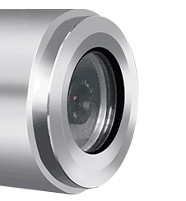
2) The product's receiving device is prone to water droplet adhesion during humid weather conditions such as rain or snow. It should be gently wiped with a soft cloth to avoid affecting the normal functionality of the product.
3) During hazy weather conditions with high dust levels, it is essential to gently wipe off dust adhering to the mirror surfaces of the receiving and transmitting devices using a damp soft cotton cloth to prevent interference with normal product functionality.

II. Product Introduction

2.1 Product Overview
Composed of a laser transceiver device, receiving device, and fixed bracket, this instrument employs the principle of laser absorption spectroscopy (TDLAS) to perform remote real-time online monitoring of methane gas concentration between the laser transceiver device and receiving device. It also features functions such as signal acquisition, conversion, and transmission.

2.1.1 Detection Principle
The measurement principle fully utilizes methane gas's absorption characteristics at a specific wavelength. When the detection beam encounters methane molecules, a portion of the beam is absorbed by them. By measuring the absorption rate, the methane concentration can be determined.

2.2 Transceiver Device
The laser transceiver system consists of a laser emission module, an adjustable mounting bracket, and a weatherproof enclosure. The laser emission module controls laser emission through an internal drive mechanism. The mounting bracket enables adjustment of the transceiver's horizontal and pitch angles to ensure stable laser emission onto the transmitting device. The stainless steel enclosure provides robust physical protection against harsh weather conditions, effectively shielding the equipment from thermal radiation and preventing operational disruptions caused by rain or snow.

2.3 Receiving Device
The laser receiving system consists of a laser receiver module, mounting bracket, and weatherproof enclosure. The laser receiver module captures laser signals through specialized receivers, while high-precision optical components perform photoelectric conversion. Processed signals undergo concentration inversion before being transmitted via data cables. The adjustable mounting bracket enables precise alignment of transceiver units by regulating horizontal and pitch angles. The stainless steel weatherproof enclosure provides robust physical protection against harsh conditions, effectively shielding equipment from thermal radiation and preventing operational disruptions caused by rain or snow.

III. Operational Procedures

3.1 Equipment Inspection
1) Check whether the equipment is intact and all data cables are properly connected and in good condition;
2) Ensure the receiving mirror is clean and regularly wipe it with a soft dry cloth.

3.2 Equipment Operation
1) After completing the above process inspection, power on and activate the device;
2) Power supply method: The device supports DC 24V power supply. The power cord equipped with this device can be connected to the on-site 24V DC power source to supply power to the device. If 24V DC power is unavailable at the site, an AC-to-DC 24V power converter can be utilized to generate stable 24V DC power for powering the device.

IV. Installation Operating Procedures

4.1 Installation Environment Requirements
The installation of this device requires the use of visible green light to calibrate the optical path between the transmitter and receiver. Under intense sunlight conditions, visible green light is difficult to observe. Therefore, it is recommended to install this device in environments with weaker sunlight (overcast days or evening hours).

4.2 Installation Location Requirements
This device is primarily designed for gas concentration monitoring in large open spaces such as long-distance pipelines, pressure regulation stations, and valve chambers. It is typically installed at pipeline valve locations or above valve chamber clusters. For outdoor installations, self-made support poles or on-site conditions should be considered; indoor installations require custom-made mounting bases or expansion bolts. Installation should avoid areas with significant vibrations or dust accumulation, with a detection range not exceeding 120 meters.

4.3 Installation Dimensions and Requirements

4.3.1 Appearance and Installation Dimension Diagram
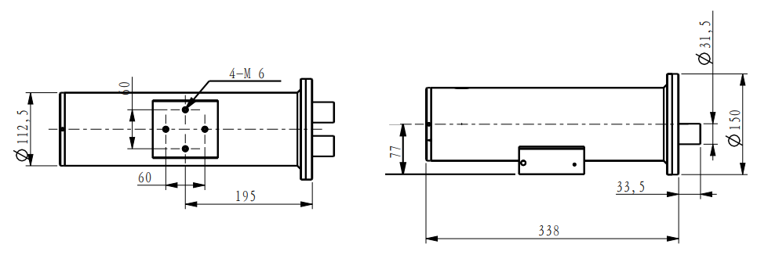

4.3.2 Installation Requirements
This device can be installed using metal pipe upright poles or flat walls depending on the on-site environment.
Wall installation method:
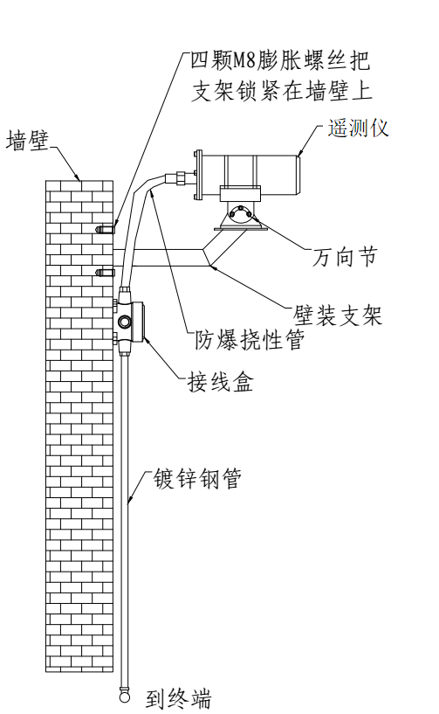
Wall mounting bracket:
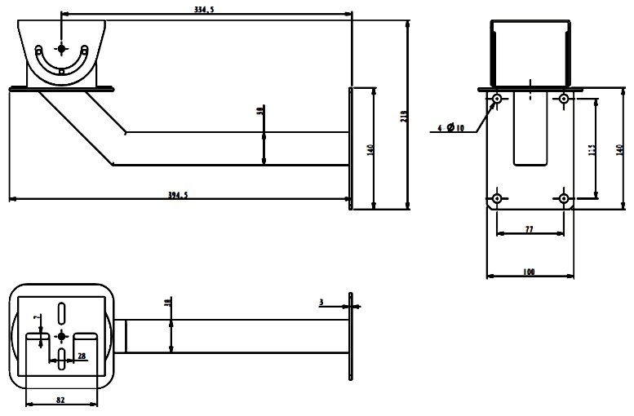
Pole installation method:
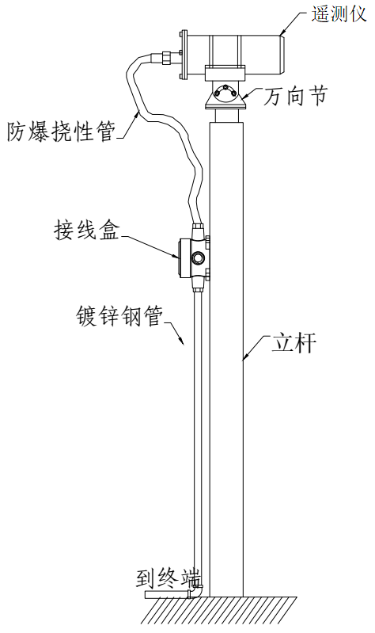

4.4 Installation Procedures and Testing Methods
(1) Pre-installation preparations: multimeter, wrench, bevel pliers, lens cleaning cloth, installation bolts, washers, nuts, etc.;
(2) Installation Steps
Preparation before equipment installation: Conduct on-site inspection to determine the installation location and height of the transmitting and receiving devices, and verify the completeness of the probes.
2) Installation and debugging of receiving and transmitting devices: Install the receiving and transmitting devices on the wall according to the site survey drawings, tighten the four fixing nuts on the mounting base, and direct the green light from the transmitting end onto the receiving plate;

4.5 Interface and Connector Installation Requirements
The power cable and signal cable are connected to the explosion-proof junction box via explosion-proof flexible hoses. The power supply and 4-20mA signal lines utilize rail-mounted quick-connect terminals for easy on-site wiring installation. Interface specifications are detailed in the table below:
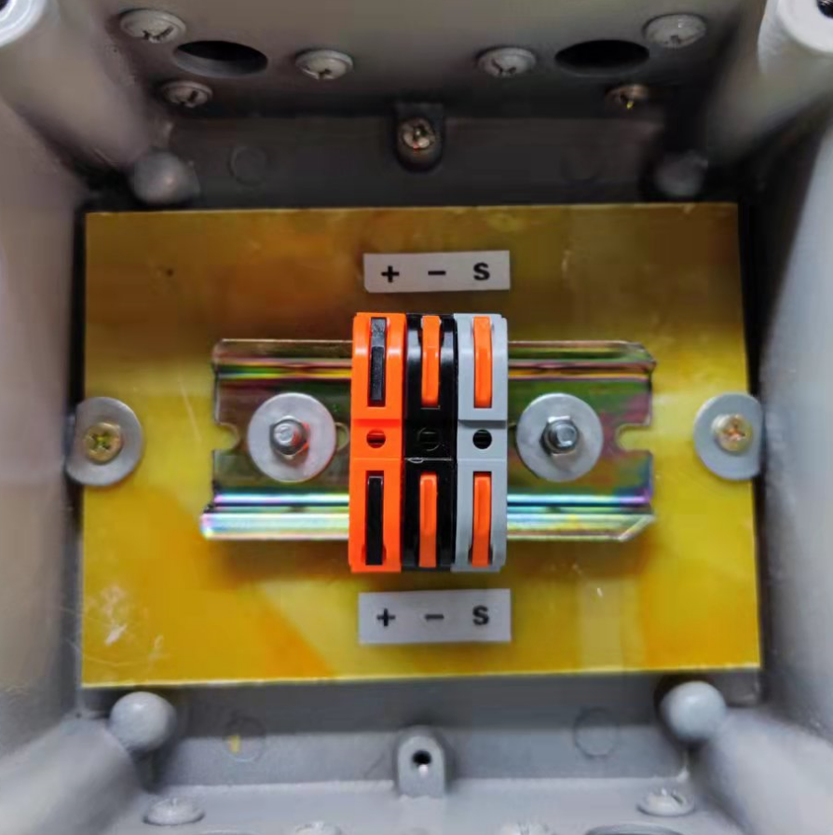

order number | Interface definition
+ | 24V+
- | 24V-
S | 4-20mA

4.6 Installation Precautions
1) During installation, live equipment operation is strictly prohibited;
2) This product is classified as precision equipment. Professional tools must be used during disassembly and assembly. Violations such as rough handling or improper operation are strictly prohibited.
3) During installation, sunlight must not direct onto the probe lens.
4) The internal components of the emission device must not be disassembled to avoid damage or contamination of the internal lenses, circuits, and laser.
5) Frequent device activation is strictly prohibited to avoid laser damage.
6) Equipment must be grounded during installation.
7) If the equipment malfunctions, immediately shut it down, notify technical personnel for maintenance, and contact our company's engineers for technical guidance.

V. Factors Affecting Accuracy
General factors affecting detection accuracy:
- In outdoor environments, the receiving end's mirror surface is prone to contamination, resulting in weaker signals and compromised measurement accuracy.
- When temperatures are high or wind speeds are strong, gas diffusion occurs more rapidly. Consequently, when leakage volumes are minimal, the escaping gas cannot be effectively contained, which may result in significant deviations in detection values.
- Under adverse weather conditions such as heavy fog or severe haze, the reception of optical signal may be weakened, thereby affecting measurement accuracy and normal operational functionality.

VI. Troubleshooting Common Faults
Common equipment failures and solutions:
question | probable cause | resolvent
The instrument is not functioning. | The device is not powered. | - Check if the power supply is functioning properly
output 2mA | The device light intensity is too strong or too weak. | - Adjust the launch device and its angle
User terminal reception  Data not available | Communication failed to connect | - Check if the interface wiring is correct

VII. Appendix

7.1 Daily Maintenance and Care
To maintain the instrument in optimal condition, perform daily maintenance as follows.
organism | Clean the device with a clean soft cloth or other specialized cloth when power is off.
organism | Warning: Do not use benzene, diluents, gaseous organic solvents, or water to clean instruments to avoid damage.
minute surface | Please gently wipe the mirror surface with a dedicated cleaning cloth or a clean soft cloth.
minute surface | Note: Do not wipe the lens with your hands or other unclean fabrics to avoid scratching the surface.

7.2 Performance Parameter Table
performance parameter
Types of gases | Methane (CH4)
test method | Laser Absorption Spectroscopy Technology
Detection range | 0～5000ppm.m
Detection distance | (0~100) meters
response time | 1 second
functional parameter
Output method | 4-20mA  Beam obstruction or signal too weak: 2mA
demarcate | Calibrated at factory
calibration | Built-in automatic calibration device
External appearance parameters
product size | Length×Width×Height: 338×155×155 (transceiver device)
Net product weight | 25±0.5Kg
power supply mode | DC24V
Electrical parameters
rated voltage | 24V
rated current | 150mA
maximum current | 0.6A
Work environment and configuration
ambient temperature | （-40～+70）℃
ambient humidity | (0–90)% RH, no condensation
atmos | 70 KPa ～ 106 KPa
Intrinsic security parameter
Power supply intrinsically safe parameters | Ui=28VDC;Ii=93mA;Ci=0;Li=0;Pi=0.65W

