Pan-Tilt Scan Laser Gas Online Monitoring System
XT-G6000C

operating instruction

Henan Otywell Electronic Technology Co., Ltd.
catalogue

I. Essential Reading Before Use 2 4
1.1 User Guidelines 2 4
1.2 Quality Assurance and Exemption Clauses 2 4
1.3 Safety Precautions 3 5
1.3.1 Precautions for Safe Operation of Instruments 3 5
1.3.2 Other Safety Precautions 3 5
1.4 Avoid using faulty 3 5
1.4.1 When using instruments in adverse weather conditions, the following precautions should be observed: 3 5
II. Component Introduction 4 6
2.1 Product Overview 4 6
2.1.1 Detection Principle 4 6
2.2 Front view 4 6
2.3 Explosion-proof Box 5 7
2.4 Pan-tilt unit dimensions and installation space dimensions 5 7
III. Installation Operating Procedures 6 8
3.1 Installation Operating Procedures 6 8
3.2 Equipment Inspection 6 8
3.3 Equipment Operation 6 8
3.3.1 Basic Operations 6 8
IV. Software Operation 7 9
4.1 Software Open 7 9
4.2 User Login 7 9
4.3 Video Signal Connection 7 9
4.4. Connection of telemetry signals 8 10
4.5. Telemetry mission initiation 9 11
4.6 Telemetry Task Stop 10 12
4.7 Alarm Point Setting 10 12
4.8. Scan Position Point Settings 12 14
4.8.1 Manual Adjustment of Position Points 12 14
4.8.2 Storage location point 12 14
4.9 Cruise Path Setting 13 15
4.10 Start cruising 13 15
4.11 View History 13 15
4.12 Telemetry Sensor Information 14 16
V. Factors Affecting Accuracy 15 17
VI. Troubleshooting Common Faults 15 17
VII. Appendix 15 17
7.1 Daily Maintenance and Care 15 17
7.2 Performance Parameters 16 18

I. Essential Reading Before Use
This instrument has been calibrated prior to factory release.

1.1 User Notice
Welcome to the XT-G6000C Fixed Laser Gas Telemetry Instrument (hereinafter referred to as the Telemetry Instrument). Before using this product, please carefully read this manual. It contains essential operational information and technical specifications that users must strictly follow to ensure proper functioning of the device. The provided guidance will also assist users in correct product operation and accurate data analysis.
This manual provides comprehensive guidance on the proper use of telemetry instruments, serving as an accurate reference for technically trained personnel or those with relevant knowledge in instrument operation and control. Before operating the instruments, ensure you fully understand the safety instructions and warnings outlined in this manual and apply them during practical operations. Due to various limitations, detailed descriptions cannot be provided for every aspect. If users require further information or need assistance with issues not covered in this manual, please contact our after-sales service hotline at 400-811-8873 for support.

1.2 Quality Assurance and Exemption Clauses
By choosing Outeiwell Technology, you are selecting high-quality products. All products from our company are eligible for free repairs during the warranty period; after the warranty period, corresponding component replacement fees will be charged. If you encounter any issues during use, please contact us for prompt assistance. The entire instrument is covered by a one-year warranty.
Any repairs beyond the warranty period or those occurring during the warranty period that involve the following faults shall be considered out-of-warranty repairs, for which no free warranty service will be provided. Outeiwell Technology reserves the right to charge any on-site maintenance fees. These faults include, but are not limited to:
1) Due to improper use (internal water ingress, corrosion, fire, or electrical interference from high-voltage circuits);
2) Force majeure (damage caused by earthquakes, lightning strikes, floods, etc.);
3) Unauthorized modification of product internals without permission;
4) Failure to use the product in accordance with the user manual and training regulations, resulting in product damage;
This manual only covers instruments and components sold to buyers by suppliers, distributors, and representatives authorized by Oteville Technologies.

1.3 Safety Precautions
Before using this instrument, please ensure that you have read and understood the safety precautions described below.

1.3.1 Precautions for Safe Operation of Instruments

warn ：
1. The instrument must be protected from radiation of high-temperature heat sources, as excessively high or low temperatures may adversely affect its operational performance and service life.
2. Avoid prolonged gaze at the laser emitter to prevent eye burns.
warn ：
1. The instrument must be protected from radiation of high-temperature heat sources, as excessively high or low temperatures may adversely affect the performance and lifespan of the transducer. 1. The instrument must be protected from radiation of high-temperature heat sources, as excessively high or low temperatures may adversely affect the performance and lifespan of the transducer.
2. Avoid prolonged gaze at the laser emitter to prevent eye burns.
3. The instrument has a metal casing. Do not touch it when powered on to avoid electric shock.

1.3.2 Other Safety Precautions
1) This instrument is classified as precision equipment. Do not attempt to disassemble, modify, or alter the device. If the instrument fails to operate normally or exhibits malfunctions, please contact us.
2) If the instrument is accidentally damaged, immediately cease operation, shut down the device after confirming environmental safety, disconnect the power supply, and contact us.
3) Output method: When RS485 output is connected to a safety zone, a safety barrier must be added to prevent external energy input before connecting with other devices; however, this is not required when connecting with intrinsically safe equipment.

1.4 Avoid using faulty components
To minimize the risk of failures, read the following carefully.

1.4.1 When using instruments in adverse weather conditions, the following precautions should be observed
This instrument is designed to prevent vertically falling water droplets from entering its interior. For humid weather conditions such as rain or snow, as well as smoggy environments with high particulate matter concentrations, the following precautions and specific solutions should be noted:
The drum-shaped window panels (glass lenses) of the product's receiving and transmitting device may accumulate water droplets during humid weather conditions such as rain or snow, which can interfere with signal reception and signal strength, thereby affecting normal operation. The accumulated water droplets should be gently wiped off using a cotton cloth.

② During weather conditions with high dust levels, it is essential to gently wipe the dust adhering to the mirror surface of the receiving/transmitting device using a damp soft cotton cloth to prevent interference with normal product functionality.

II. Component Introduction

2.1 Product Overview
This product consists of a host unit and a host computer, utilizing the principle of laser absorption spectroscopy to perform remote real-time online monitoring of methane gas concentration within the detection area of the laser transceiver device. It is an instrument equipped with functions such as signal acquisition, conversion, and transmission.

2.1.1 Detection Principle
The detection mechanism fully utilizes methane gas's absorption characteristics at a specific wavelength. When the detection beam encounters methane molecules, a portion of the beam is absorbed by them. By measuring the absorption rate, the methane concentration can be determined.

2.2 Front view

Pan-Tilt Head
Transmission and reception device Camera Transmission and reception device Camera

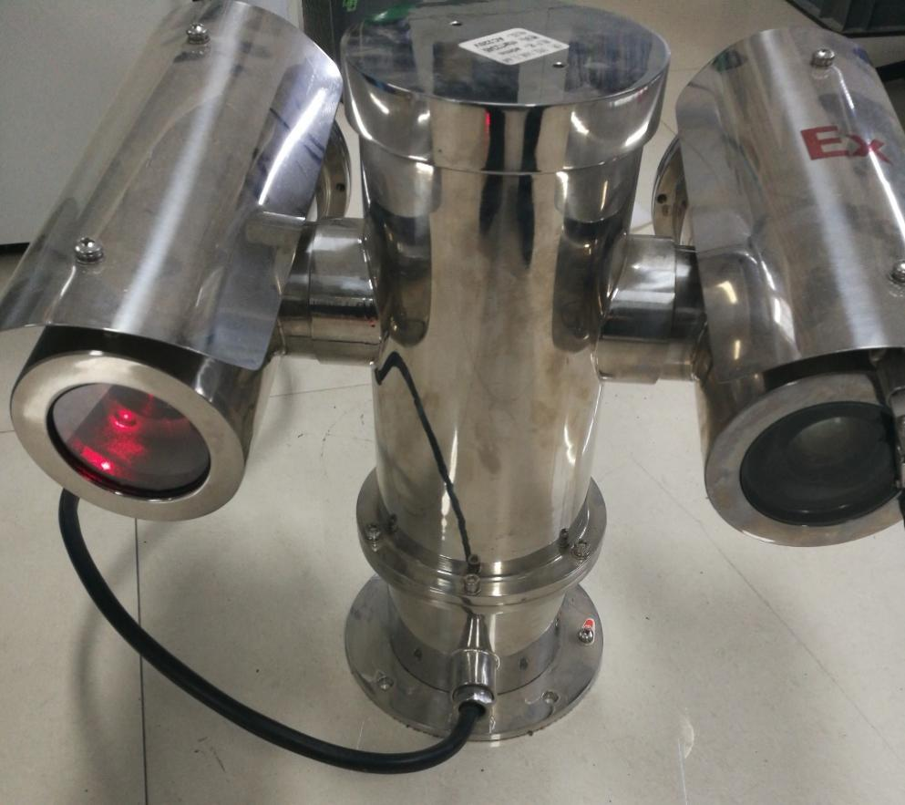

2.3 Explosion-proof Box
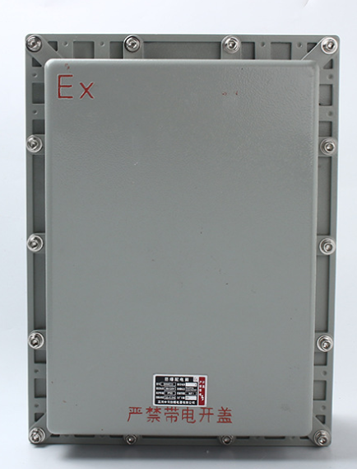

2.4 Pan-tilt Unit Dimensions and Installation Space Dimensions

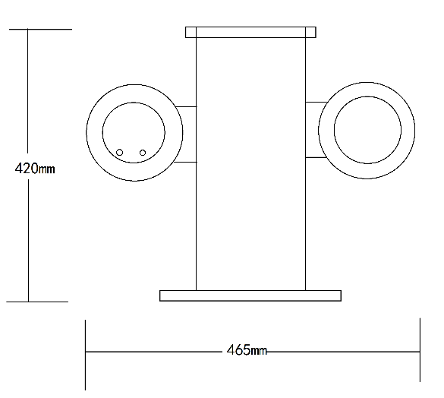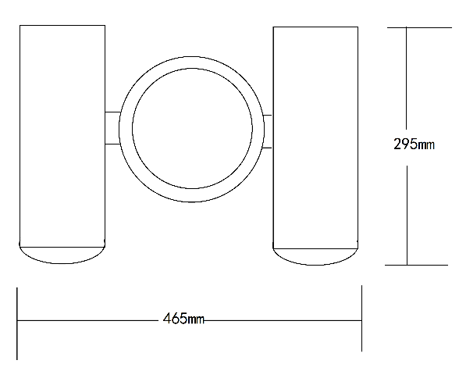
outline dimensional drawing

III. Installation Operating Procedures

3.1 Installation Operating Procedures
1) First install this equipment at the designated location;
2) Connect the PTZ output to the explosion-proof box via an explosion-proof hose. The explosion-proof box provides 220V power supply, RS485 interface, and video network interface.
3) Connect the AC 220V external power cable to one end of the explosion-proof switch, then connect the output power cable from the switch to a 220V socket.
4) Transmit RS485 signals and video signals to the computer monitoring terminal.
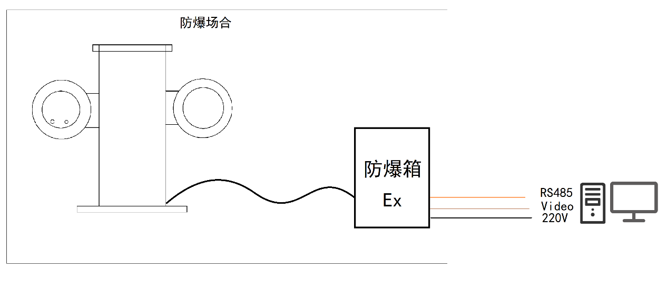
Explosion-proof hose
Cloud Platform

3.2 Equipment Inspection
1) Check whether the equipment is intact and verify that all optical fibers and power cables are properly connected and in good condition;
2) Check whether the mirror surface of the receiving and transmitting device is clean, and regularly wipe it with a soft dry cloth.

3.3 Equipment Operation

3.3.1 Basic Operations
1) After completing the above process inspection, activate the explosion-proof switch and power on the equipment;
2) Upon initial power-on, the gimbal performs a self-test rotation cycle.
3) Launch the detection software and initiate monitoring.

IV. Software Operation

4.1 Software Open
Click the desktop icon to start the software.

4.2 User Login
1. Click User/Help on the toolbar and select Sign in
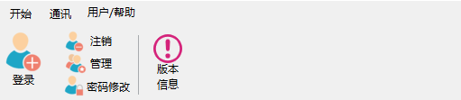
2. Open the login dialog box
Select the administrator default password "5656"
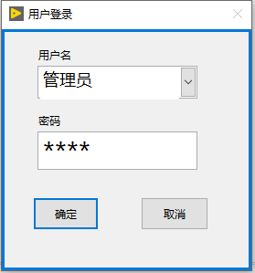
Click OK to sign in.

4.3 Video Signal Connection
1. Click "Communications" on the toolbar, then select "Connect" to open the video signal connection dialog box.
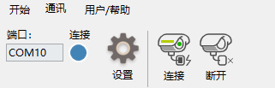

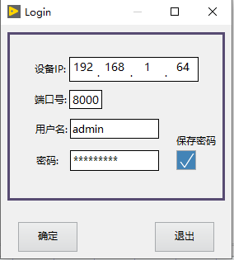
2. Enter the IP address, port number, username, and password for the video signal (information is stored on the cloud platform). Click "OK" to connect.
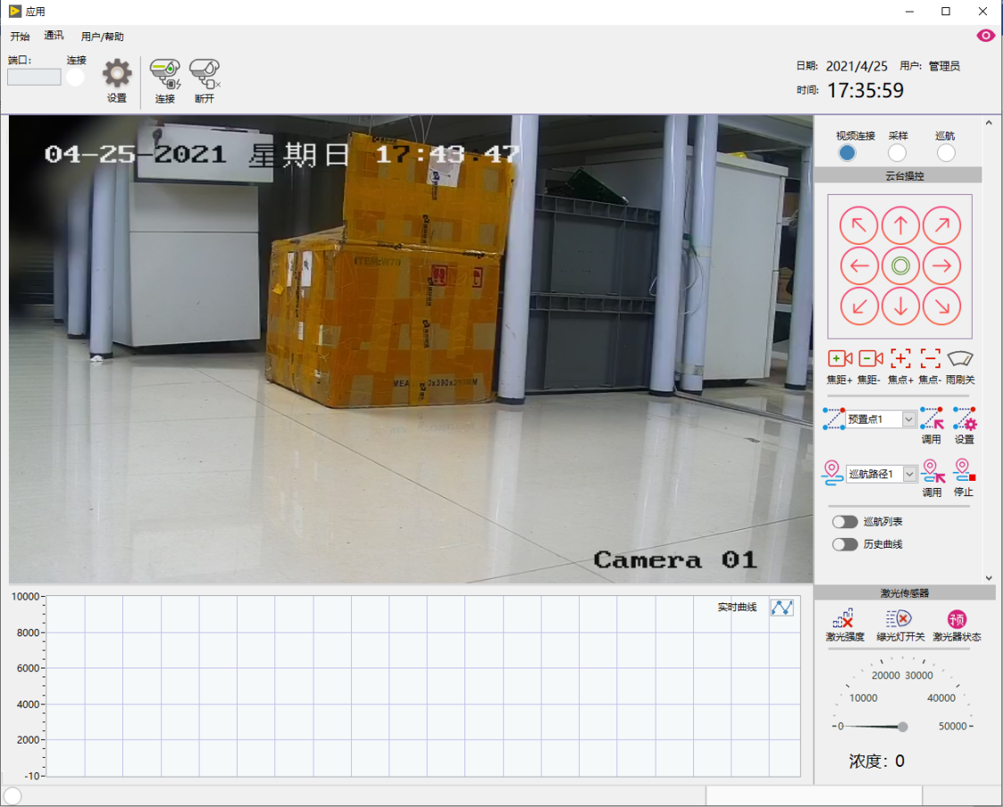

4.4. Connection of telemetry signals
1. Click Settings under Communications in the toolbar to open the settings dialog box
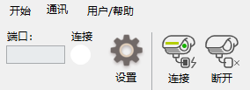
2. Select the port resource from the VISA resource name dropdown list, click "Test Connection" to establish the connection when the green light turns on, then click "OK" and finally "Exit".
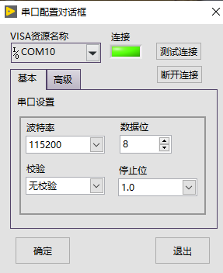

3. After successful connection, the toolbar and connection light will turn on
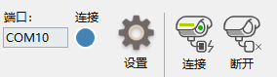

4.5 Telemetry mission initiation
Click Start on the toolbar, then click Task Start to begin the telemetry task.
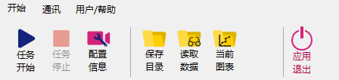

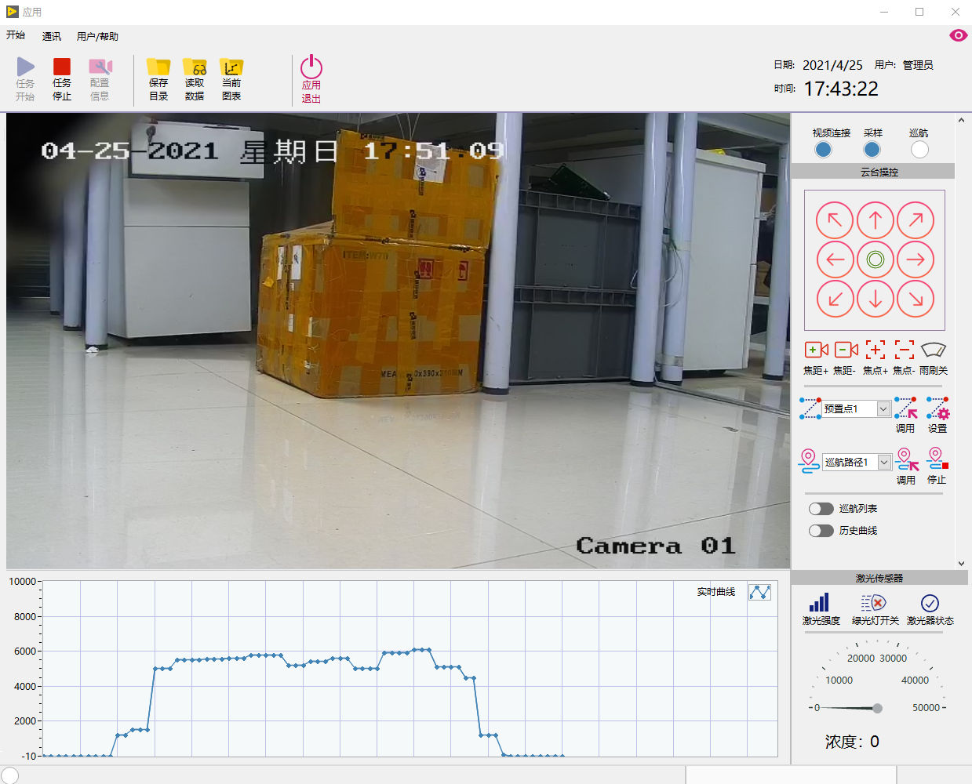

4.6 Telemetry mission termination
Click Start on the toolbar, then click Stop Task to halt the telemetry task.
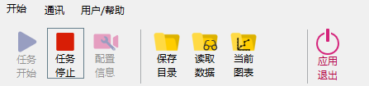

4.7 Alarm Point Configuration
1. Click Start on the toolbar, then select Configuration Information to set alarm points
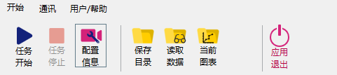

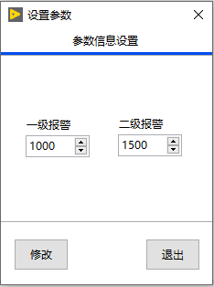
Figure 4.7.1 Alarm Point Configuration
2. Click Modify, then Exit

4.8. Scan Position Point Settings

4.8.1 Manual adjustment of position points
After connecting the video signal, you can set position points and adjust them vertically and horizontally on the right side of the software.
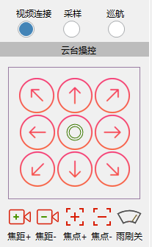

4.8.2 Storage location point
1. After manually adjusting the position points, save them by clicking the "Cruise List" tool in the software's right toolbar.
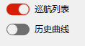
2. The software cruise table is displayed as follows
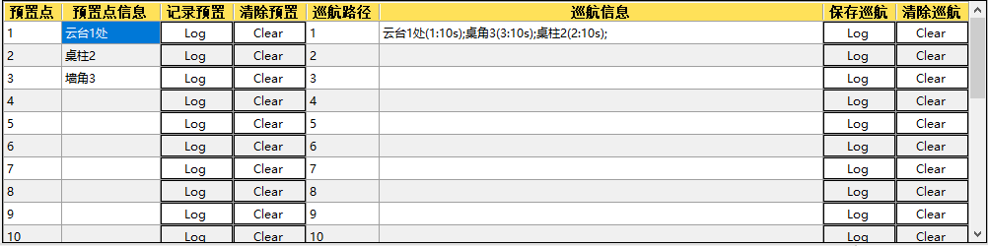
3. Click the record location to open a window. Save the name of the record point, such as "Wall Corner," then click OK.
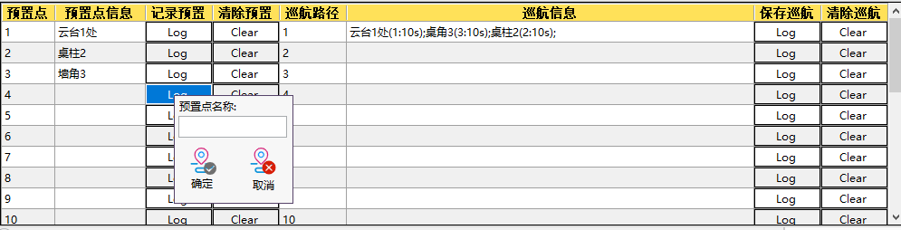

4.9 Cruise Path Setting
After setting the position points in 4.8, you can combine them into a cruise path.
Add to cruise path
In the preset point information bar, right-click to open a dialog box and add to the specified cruise path.
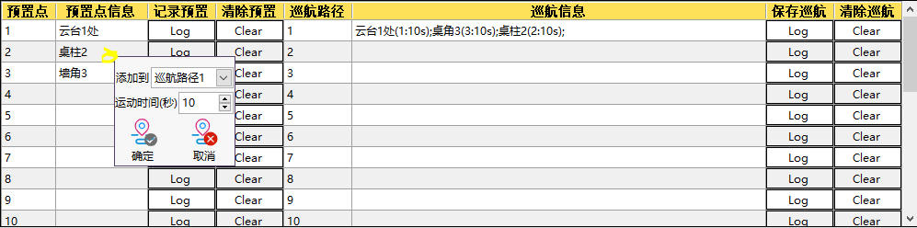
2. Set the movement time, which represents the duration of stay at the specified location.
3. After adding multiple waypoints to the cruise path, click "Save Cruise" to save the route.
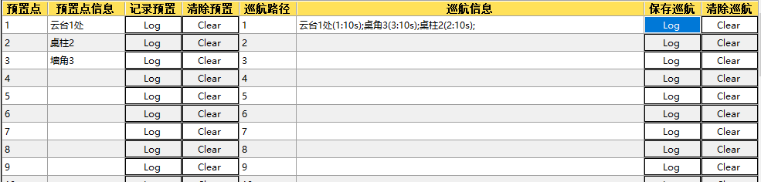

Cruise mode starts at 4:10
Select the corresponding cruise path number and start calling
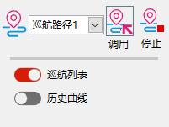

4.11 View history
1. Click "Read Data" on the toolbar to open the dialog box and select the corresponding date
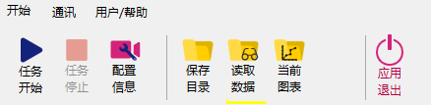
2. Click 'Historical Curve' on the right side of the software to switch to historical curve display.
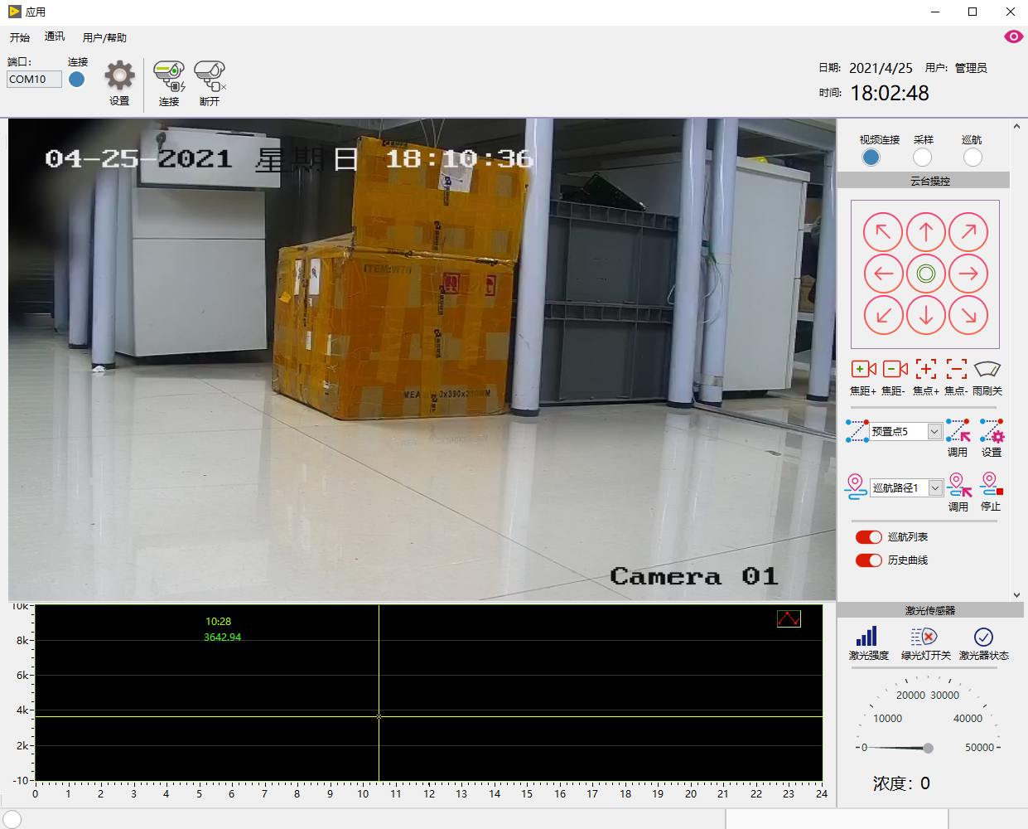
3. Click "Historical Curve" again to return to the normal real-time curve display interface

4.12 Telemetry Sensor Information
Laser intensity: indicates the current signal strength of the sensor.
Red light switch: Indicator light switch.
Laser status: Whether the laser is operating normally.
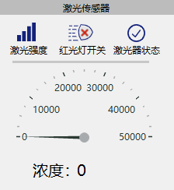

V. Factors Affecting Accuracy
When temperatures are high or wind speeds are strong, gas diffusion occurs more rapidly. Consequently, when leakage volumes are minimal, the escaping gas cannot be effectively contained, which may result in significant deviations in detection values.

VI. Troubleshooting Common Faults
question | probable cause | resolvent
The instrument is not operational | The power switch is not turned on | Turn on the instrument's power supply
User terminal reception  Data not available | Severe mirror contamination of the window | Wipe the mirror surface with a clean soft cloth.
User terminal reception  Data not available | Data transmission interruption | Check if the data transfer connection was established successfully

VII. Appendix

7.1 Daily Maintenance and Care
To maintain the instrument in optimal condition, perform daily maintenance as follows.

minute surface | Please gently wipe the mirror surface with a dedicated cleaning cloth or a clean soft cloth.
minute surface | Note: Do not wipe the lens with your hands or other unclean fabrics to avoid scratching the surface.

7.2 Performance Parameters
performance parameter
Types of gases | Methane (CH4)
test method | Laser Absorption Spectroscopy Technology
Detection range | （0～50000）ppm·m
sensitivity | 5 ppm·m
Detection distance | (0–100) meters
response time | 0.1 seconds
Horizontal rotation angle | 0°～360°
Vertical rotation angle | -90°～90°
levels of protection | IP68
Continuous working time | >25,000 hours
functional parameter
Alarm setting | You can set warning and alarm thresholds
Output method | RS485
demarcate | Calibrated at factory
calibration | automatic calibration
External appearance parameters
product size | Length×Width×Height: 465×295×420
Net product weight | 30±0.5Kg
power supply mode | AC 220V
explosion-proof sign | Ex db IIC T6 Gb / Ex tb IIIC T80℃ Db
Electrical Parameters of Optical Machine Structure
rated voltage | 5V
rated current | 0.8A
power rating | 4W
Maximum number of loops | 12
Maximum total switch current | 0.8A
Maximum loop current | 0.8A
laser power | ≤10mW
Work environment and configuration
ambient temperature | （-20～+50）℃
ambient humidity | (0–95)% RH, no condensation
atmos | 70 KPa ～ 106 KPa

