Otywell ®

Gas Alarm Controller GDB9/GDB10
operating instruction

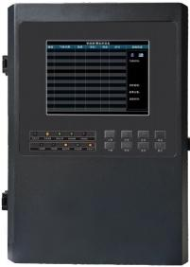

Henan Otywell Electronic Technology Co., Ltd. is an ISO9001 Quality Management System Certified Enterprise
Printed version: OT20250919-V1.01

Thank you for choosing Henan Outewell Electronic Technology Co., Ltd. products.
Please keep this manual properly for easy reference and assistance when needed in the future.

Copyright Statement

This manual is copyrighted by Henan Outeiwell Electronic Technology Co., Ltd. Without written permission, no part of this manual may be reproduced, translated, stored in databases or retrieval systems, or disseminated through any means or methods such as electronic transmission, photocopying, or audio recording.
Henan Outaiwei Electronic Technology Co., Ltd. adheres to the principle of technological advancement, continuously striving for product improvements and performance enhancements. The company reserves the right to make any product modifications without prior notice.
If users install, repair, or replace components without following the instructions in this manual, they shall bear all resulting liabilities.
User Service Guide
1. Before using this product, please carefully verify the completeness of accessories, product qualification certificate, and factory inspection report according to the product's factory list. If any deficiencies are found, immediately contact the seller or manufacturer.
2. For twelve months from the date of sale, if the product quality falls below the technical specifications due to user compliance with storage, transportation, and usage requirements, free repair services will be provided upon presentation of the warranty certificate.
3. For damages caused by violation of operational regulations and requirements, malfunctions resulting from repairs performed by non-designated authorized technical service departments, or product quality issues arising from force majeure factors, our company will charge for repair services.
4. When undergoing product repair, please proactively present the product warranty card. Failure to present the warranty card will result in rejection as a receipt.
maintenance fee.
5. After product maintenance or repair, please present this manual. The maintenance technician will complete and sign the attached "Maintenance and Repair Status Record." Additionally, please sign the technician's record to confirm the maintenance details and provide feedback. For institutional users, please affix the official seal.
6. If you have any questions or concerns regarding the products and services we provide, including product technology, quality, installation and maintenance, service attitude, or pricing policies, please contact us promptly. We will address your feedback in a professional manner.

Declaration: The gas alarm controller is referred to as 'controller' in this manual.

catalogue

I. Overview 01 01
II. Main Technical Parameters 01 01
III. System Composition 02 02
IV. System Architecture and Installation 02 02
V. System Function Operation Instructions 08 08
VI. Common Faults and Solutions 15 15
VII. Warranty and Maintenance 16 16
8. Storage 16 16
IX. Accessories 16 16

The GDB9/GDB10 Gas Alarm Controller (hereinafter referred to as the Controller) is a product developed by our company, capable of processing multiple 4~20 mA/RS485 signal channels simultaneously. It features excellent stability, high accuracy, and intelligent parameter configuration. With abundant external control ports, users can freely select detector types and connection ports, enabling on-site monitoring and alarm systems through simple setup and wiring.
The controller is primarily used for monitoring flammable gases, displaying numerical indicators of the gas to be tested. When the concentration of a specific gas under test at the site fails to meet the preset standards, the system automatically triggers a series of alarm actions, such as audible alarms, exhaust ventilation, or tripping (depending on user configurations).
Years of market application have demonstrated that this product features user-friendly design, outstanding performance, stable and reliable operation, convenient installation and maintenance, as well as comprehensive gas measurement capabilities. It fully meets the requirements of industrial safety monitoring for high equipment reliability, operational stability, and diverse gas measurement options.
Gas alarm controllers are widely used in industries such as military, mining, healthcare, petrochemicals, metallurgy, animal husbandry, refining and chemical processing, gas transmission and distribution, production process control, environmental protection, and water treatment.
The design, manufacture, and verification of this product comply with the following national standards:
GB/T191-2008 Packaging, Storage and Transportation Diagrammatic Marking
GB9969.1-1998 General Principles for Instruction Manuals of Industrial Products
GB12358-2024 General Technical Requirements for Gas Detection and Alarm Instruments in Workplace Environments

II. Main Technical Parameters
Installation method: Wall-mounted
Indication method: Color LCD display, audio-visual alarm
Working environment temperature: -10℃~+50℃
Working environment humidity: (20～93)%RH
Main power supply: AC220V±15%,50Hz±1% (main power fuse 3A)
Power: ≤10W
Detector power supply voltage: DC24V (1±15%)
Backup power undervoltage alarm threshold: DC21V±1V
Requirements for the connection cable between the detector and the host unit: GDB9: ≥RVVP3×1.5mm²
GDB10: ≥RVVP4×1.5mm² Detector and host communication distance: ≤1000m

Detector interface:
GDB9: Three-point line interface, capable of receiving gas detectors with output signals of (4~20) mA current signals
GDB10: Four-bus interface capable of receiving gas detectors with RS485 output signals
(The exact number of detectors to be connected depends on actual requirements.) Product dimensions: L435mm × W300mm × H118mm (The exact number of detectors to be connected depends on actual requirements.) Product dimensions: L435mm × W300mm × H118mm
Product weight: approximately 8.5 kg
Alarm record: ≥60000 (replaceable with high-capacity memory card for additional storage)
Passive switches: 6 sets
Network port: 1 group
After alarm activation, audible and visual alarm signals can be generated and maintained until manual reset. The alarm sound signal can be manually silenced.

III. System Composition
The entire system consists of a gas alarm controller and a gas detector. The controller is responsible for real-time data feedback from the detector and implementing corresponding linkage measures.

IV. System Architecture and Installation
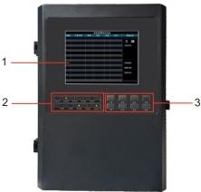
4.1 Controller Appearance Structure

order number | name
1 | display space
2 | status indicator area
3 | Button operation area

4.2 Structure of Main Components in the Controller
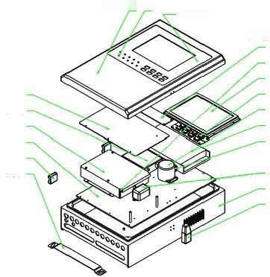
1 Case Door Indicator Light
Case mask
Button indicator circuit board

 | cell
motherboard · | screen  key
4GDTU- | Lamp
Battery fixed housing liner plate | source  Power supply bracket
Hinge-Case Mounting Bracket | filter  chassis  Case door

4.3 Product Dimensions
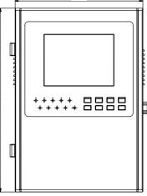
300
118
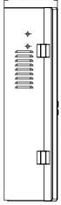

435

4.4 Fixed Installation of Controllers
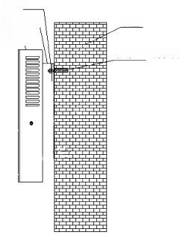
nut _
wall
Mounting bracket Controller
pinion gear, metal pinion gear

Installation location: Non-explosion-proof environment, duty room, or areas with frequent personnel access.
Installation height: Keep it at a height of 1.4 meters from the ground for easy operation.
way to install ：
A. Please drill two fixing holes on the wall with a horizontal distance of 180mm and a diameter of 6mm.
B. Secure the mounting plate to the wall using a φ6 plastic expansion plug.
C. Hang the mounting hook on the back of the controller onto the installation plate.

4.5 Controller Wiring Terminals 4.5.1 GDB9
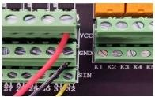
graph 4-1

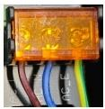
graph 4-2

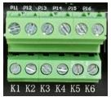
graph 4-3

Figure 4-1 shows the detector terminal connections. The controller has 32 channels, with each detector corresponding to one channel on the host. The controller's terminals include three connection points: VCC positive terminal, GND negative terminal, and SIN signal terminal. These should be connected to the detector's terminals: positive terminal, negative terminal, and signal terminal.
Note: Do not connect wires in reverse or with poor connections, as this may cause circuit failure!
Figure 4-2 shows the power terminal wiring of controller AC220V, where L denotes the live wire, N the neutral wire, and E the ground wire.
Figure 4-3 illustrates the passive switch signal output terminals of the controller relay, comprising six groups. Trigger conditions can be configured in the controller menu according to user requirements. "K1" denotes Relay No.1, with subsequent numbers following the same naming convention. The relays support four operational modes: Low-Level Output, High-Level Output, Fault Output, and Alarm Output. Each relay's operational mode is configured through the main menu's relay mode settings. The relays can operate in zoned modes to control specific interval ranges.

Internal state output.
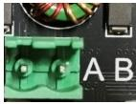
graph 4-4

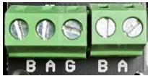
graph 4-5

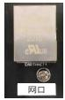
graph 4-6

Figure 4-4 illustrates the controller uploading wiring terminals to the 4G IoT platform (transmitting all detection data). "A" represents a 485 signal, and "B" represents another 485 signal (the wiring sequence must remain consistent to prevent equipment malfunctions). (Optional feature)
Figure 4-5 shows the controller 485 uploading wiring terminals, with two interface groups available for uploading only gas concentration information. It can connect to graphic display devices, computers, and other equipment. "A" represents the 485 signal, and "B" represents the 485 signal (the wiring sequence must remain consistent to avoid equipment malfunctions).
Figure 4-6 shows a set of Ethernet interfaces for uploading IoT data (optional feature).
4.5.2 GDB10
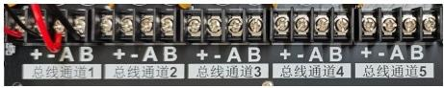
graph 4-7

The controller features five circuits, each capable of connecting multiple detectors. Figure 4-7 illustrates the wiring terminals between the controller and detectors. The "+" terminal represents the controller's positive terminal, the "-" terminal represents the negative terminal, "A" denotes the 485 signal, and "B" also indicates the 485 signal (the wiring sequence of the controller must remain consistent to prevent malfunctions). The four connection points—the positive terminal "+" and negative terminal "-" along with terminals "A" and "B" —should be directly connected to the corresponding terminals on the detectors: positive terminal "+" and negative terminal "-" for the detectors, and terminals "A" and "B" respectively.
Note: Do not connect wires in reverse or with poor connections, as this may cause circuit failure!

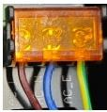
graph 4-8

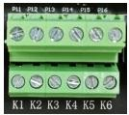
graph 4-9

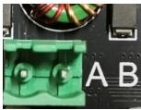
graph 4-10

Figure 4-8 shows the power terminal connections of controller AC220V, where L denotes the live wire, N the neutral wire, and E the ground wire.
Figure 4-9 displays the passive switch signal output terminals of the controller relay, comprising six groups. Trigger conditions can be configured in the controller menu according to user requirements. "K1" denotes Relay 1, with subsequent relays following the same naming convention. The relays support four operational modes: Low-Level Output, High-Level Output, Fault Output, and Alarm Output. Each relay's operational mode is configured through the main menu's relay settings. The relays enable zoned operation to output status signals within designated control zones.
Figure 4-10 illustrates the controller uploading 4G IoT platform terminal blocks (transmitting all detection data). "A" represents a 485 signal, and "B" represents another 485 signal (the wiring sequence must remain consistent to prevent equipment malfunctions). (Optional)

function ）

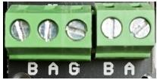
graph 4-11

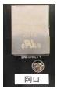
graph 4-12

Figure 4-11 shows the controller 485 uploading wiring terminals, with two interface groups exclusively for gas concentration data transmission. It can connect to graphic display devices, computers, and other equipment. "A" represents the 485 signal, while "B" also represents the 485 signal (the wiring sequence must remain consistent to avoid equipment malfunctions).

Figure 4-12 shows a set of Ethernet interfaces for uploading IoT data (optional feature).
Figure 4-11 shows the controller 4 8 5 uploading wiring terminals, with two interface groups exclusively for gas concentration data transmission. It can connect to graphic display devices, computers, and other equipment. "A" represents the 4 8 5 signal, while "B" denotes the 4 8 5 signal (the wiring sequence must remain consistent to prevent equipment malfunctions).
Figure 4-12 shows a set of Ethernet interfaces for uploading IoT data (optional feature).
4.6 System Installation of Controllers
The system installation diagram of the GDB9 controller is shown in Figure 4-13.

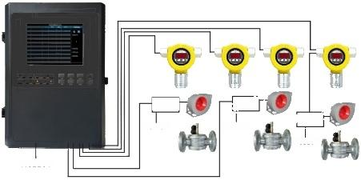
coincidence cabinet
Control cabinet
AC220V Interlocking Cabinet AC220V Interlocking Cabinet
AC220V
AC220V
AC220V
graph 4-13
The system installation diagram of the GDB10 controller is shown in Figure 4-14.

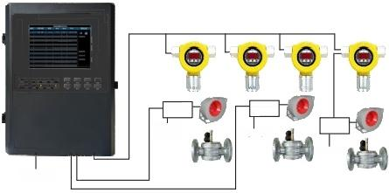
Control cabinet
Control cabinet
Control cabinet
AC220v
AC220V
AC220V
AC220V
graph 4-14

4.6.1 Installation Precautions
(1) Select appropriate gas detectors based on the on-site operating environment.
(2) Determine the wiring path based on the detector type. As shown in Figures 4-13 and 4-14, bus detectors can be connected in parallel to the main bus using a T-shaped connection method, while each split-line detector requires a (RVVP3×1.5mm²) cable for connection.
(3) Select appropriate conductors based on the number of detectors and wiring distances (it is recommended to use single-strand conductors with a cross-sectional area greater than 1.5 mm²).
(4) The address codes of bus detectors must not be duplicated, as this may interfere with signal communication between other detectors and the controller.
4.6.2 Installation Steps
(1) Controller Installation: Select a secure location free from flammable gases, corrosive gases, cooking fumes, dust, and rain exposure for controller installation. Secure mounting brackets to walls using metal expansion tubes or expansion pins, then mount the controller onto the brackets. The controller should be installed in a manned area to ensure prompt response during alarms. It is recommended to connect the controller housing to a ground wire to prevent communication interference.
(2) Detector Installation: Select an installation location at the detection site free from corrosive gases, cooking fumes, and dust, avoiding water immersion. Secure the detector or actuator to the detection site using expansion joints, screws, or steel protective sleeves, ensuring sealed interfaces. The controller power supply must be turned off prior to detector installation and restored only after completion.
(3) System Wiring: Wiring shall only be performed after the controller, detectors, and other equipment have been securely installed. Ensure the power supply is disconnected, open the detector or actuator junction box cover, connect the cables to corresponding terminals, and then close and securely fasten the junction box cover. During system operation, ensure correct wiring between the controller and detectors. Special attention must be paid to preventing reverse connections of power lines and signal lines, as such connections may cause detector damage. Reversal of positive and negative polarity on signal lines will not result in detector burnout.
The detector may experience address loss during operation.
(4) Power supply connection: After verifying the accuracy of all wiring connections, connect the system power supply.

V. System Function Operation Instructions
Connect the power supply (main and backup power). The device will automatically start, with the LCD displaying the "Startup Interface". While showing the startup interface, system parameters are initialized. After approximately 180 seconds, the "Monitoring Interface" appears, indicating the device has entered normal monitoring mode.

5.1 Description of the Detection Interface

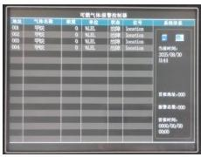
characteristic | explain
channel | Channel bit number of detector connection controller
Gas name | Name of the gas to be detected
Concentration | Display of concentration connected to the detector
unit | Unit name for measuring gas
state | Check the detector's operational status
item | Number the detectors based on their installation positions
system info | Memory card status, current time, first alarm channel (the channel that triggers the earliest alarm)  First alarm time (the earliest alarm channel time) and total alarm count  Total number of alarm detectors displayed
5.2 Key Description

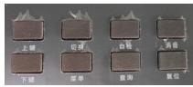
key | explain
Menu buttons | Enter the menu interface (password "1111")
Up/Down arrow keys | Detect multiple peak states (three or more gases) after switching interfaces and scroll up/down
Query button | You can access the historical alarm record query interface. Click the menu button to return to the initial interface.
Toggle key | Toggle display mode. Press the up/down keys to view multiple gas types (three or more) when detecting.

an erase button | After the alarm sound is triggered, press the mute button. The red light will illuminate and the sound will stop until the next alarm is triggered.
Reset button | After the alarm point returns to normal, press the reset button to restore the normal detection interface (password "2222").
Self-check button | Automatically detect parameters and hardware devices; trigger an alarm when self-checking detects issues (password "2222")
5.3 Indicator Light Description

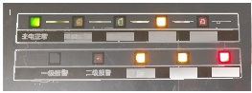

Primary power failure, standby power activation, supervisory power failure, charging indication
Language and signaling failure System fault release Elimination indication
characteristic | explain
Primary power supply normal | Under normal operating conditions, the green indicator light remains illuminated.
Primary power failure | The yellow indicator light remains on after the main power is disconnected (it turns off when the main power is restored).
Backup power is functioning normally | Under normal operating conditions, the green indicator light remains illuminated.
Backup power failure | The yellow indicator light remains on after the backup power is disconnected (it turns off when backup power is restored).
charging indicator | The backup power indicator does not illuminate when fully charged, but flashes red during charging.
Level 1 alarm | When the detector concentration exceeds 20% of the Lower Explosive Limit (LEL), the red indicator light remains illuminated.
Secondary alarm | The red indicator light remains on when the detector concentration exceeds 50% of the Lower Explosive Limit (LEL).
Communication failure | The yellow indicator light remains illuminated when the detector disconnects.
system failure | The yellow indicator light remains on when the controller issues any fault type signal.
Silencer indication | The controller emits an alarm sound, and the red indicator light remains illuminated after noise suppression.
5.4 Menu Function Description
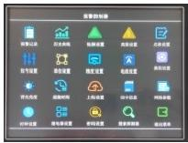
The controller offers extensive configuration options. To access the main menu interface, press the menu button, enter the password "1111" on the touchscreen, confirm, and tap OK again.
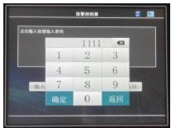

Note: The controller menu items pass factory inspection. If you need to modify key parameters, it is recommended to consult the manufacturer before making any changes. Unauthorized modifications are strictly prohibited.
(1) Alarm records: By tapping the alarm records on the screen, historical alarm records can be queried, clearly displaying recently monitored alarm records. For storing a large number of alarm records, an SD memory card must be inserted into the motherboard, as shown in Figure 5-1.
(2) Historical curve: Clicking the historical curve on the screen displays the variation curves of gas concentration values across channels for a predefined time period prior to the current time. The ▲ V key on the screen can be used to adjust channel display settings, as shown in Figure 5-2.
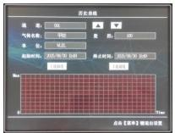
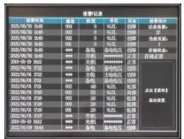
Figure 5-1 Figure 5-2 Figure 5-1 Figure 5-2
(3) Low alarm threshold setting: Used to configure the lower alarm threshold for sensors. This product allows modification of the lower limit alarm value via touchscreen interaction. To adjust the threshold, tap the input button on the screen, enter the desired low alarm value, and click Save to complete the modification. As shown in Figure 5-3.
(Note: The default underreporting value for this product is 20% LEL, with an adjustable range of 0–99% LEL.)
(4) High Alarm Setting: Used to configure the high alarm threshold for sensors. This product allows modification of the upper limit alarm value via touchscreen interaction. To set the high alarm value, tap the input button on the screen, enter the desired threshold, and click Save to complete the adjustment. As shown in Figure 5-4.
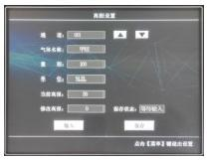
(Note: The default high reporting value for this product is 50% LEL, with an adjustable range of 0–99% LEL.)
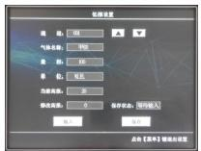
graph 5-3
graph 5-4
(5) Name configuration: Click the ▲V key on the screen to change the detection gas name, such as methane, sulfur dioxide, or carbon monoxide. Press the ▲ key to locate the name of the target gas, then click Save after identification. As shown in Figure 5-5.
This product defaults to methane detection.

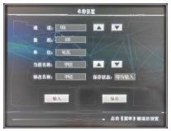
(6) Bit number configuration: Set the on-site detector location code to enable rapid address localization during alarm transmission. Press the ▲V key on the screen to adjust detector channels, then click "Input" to manually enter the controller location code (maximum 8 digits including alphanumeric characters). Save settings to complete configuration as shown in Figure 5-6.

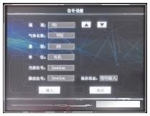
Click non-implementation storage self-use
Figure 5-5 Figure 5-6 Figure 5-5 Figure 5-6
(7) Unit settings: Click the ▲ V key on the screen to change the gas concentration unit. For example, when debugging "%VOL",
Click the screen to modify the V key corresponding to the unit, which displays "%VOL". Click Save to select the unit based on your needs, as shown in Figure 5-7. (The default unit for this product is "%LEL")
(8) Precision settings: You can modify the number of decimal places for the detector's displayed concentration. To set it, tap the screen.
▲The V key sets the measurement value to decimal places, such as one decimal place. Click Save to measure one decimal place. See the figure.

As shown in Figure 5-8. (This product defaults to no decimal places)
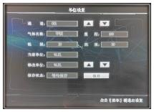
graph 5-7

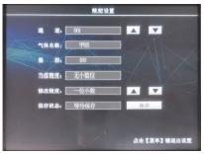
graph 5-8

(9) Current settings: Controller zero calibration. As shown in Figure 5-9, press the ▲ button on the screen to select the channel based on the connected sensor. For example, when connecting 32 channels as shown in Figure 5-10, select channel 32. If the zero current during connection is 662, calibrate the original AD value to 662. Use the ▽ button to adjust the original AD value to 662, then click Save.
(10) Range setting: Modify the detection range. Method: Tap the input field at the lower left corner of the screen, enter the desired range, and tap Save. As shown in Figure 5-11. (The default methane detection range for this product is 100)

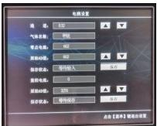
graph 5-9
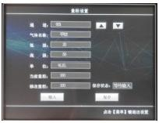
graph 5-11

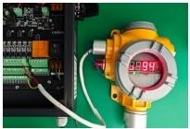

graph 5-10
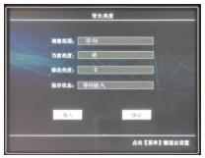
graph 5-12

(11) Backlight brightness: Adjust screen brightness. Method: Tap the input field at the lower left corner of the screen, enter the desired brightness value (range: 32–64), and adjust as needed. After inputting, tap Save.
The change was successful. See Figure 5-12.
(12) Inspection interval: Change the automatic page-turning time. If the input value is less than 10 seconds, manual page-turning is the default.
If frequent monitoring or periodic observation of multiple gases is required (as needed), click to input the appropriate interface time for gas detection conversion, then click Save to confirm modifications. As shown in Figure 5-13.

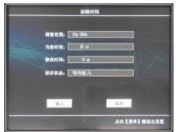
graph 5-13

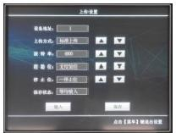
graph 5-14

(13) Upload settings: Configure upload parameters. Important parameters should not be modified arbitrarily by non-company professionals! As shown in Figure 5-14.
(14) SD Card Information: View memory card details. This product uses a 7420MB SD card for data storage, as shown in Figure 5-15. If storage space is insufficient, format the card if parameters are not critical—do not attempt this unless absolutely necessary!
(15) Network parameters: View network configuration information as shown in Figure 5-16. Key parameters, such as those not exclusively provided by our company

Do not arbitrarily transfer personnel!
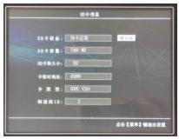
graph 5-15

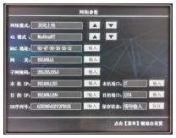
graph 5-16

(16) Clock Settings: Time adjustment. If the time is incorrect, tap the ▲ button on the screen to modify it. To add a month, tap the ▲ button on the corresponding row once to increase the month from 3 to 4; to decrease it, tap the same button once to change the month from 4 to 2. Other buttons follow the same principle—use the touchscreen to select the correct time. After completing the settings, tap the save button at the bottom right to finalize the changes, as shown in Figure 5-17.

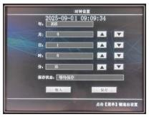
graph 5-17

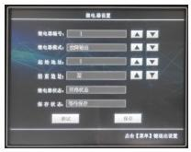
graph 5-18

(17) Relay Configuration: Set up relay zones. This product is equipped with 6 relays, allowing selection of numbered range intervals for zone control. For example, for Relay No.1, select fault output mode, set the starting address to 1, and choose the ending address.

Step 5: Select the second partition. Tap the ▲ button on the screen's relay number row to designate Relay 2 as the starting address, then adjust it to 6 by clicking the same button, and similarly set the end address to 10. This configuration can be repeated multiple times (maximum 6 partitions). Relay mode debugging options include high-level output, low-level output, and alarm output, with partitioning methods remaining consistent as shown in Figure 5-18.
(18) Password Settings: Change the menu login password. Method: Tap the input field at the lower left corner of the screen, enter the new four-digit password to be changed, and tap Save to complete the modification. As shown in Figure 5-19.
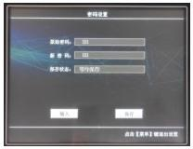
graph 5-19
(19) Search Detector: Search for new detectors. To add a detector, ensure the connection is completed and click Start. When the save status shows: Search completed, click Save. As shown in Figure 5-20 and Figure 5-21.

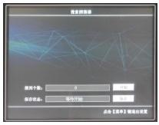
graph 5-20
(20) Exit menu: Return to the normal monitoring interface.

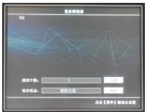
graph 5-21

1. No display upon startup: In most cases, the issue lies in the system power supply component. Carefully inspect the power supply circuit or consult a professional for repair.
2. Power-on display failure: indicates either no detector connection or poor contact in the detector's lead wire.

3. After connecting the detector, the detector displays normal operation but the controller shows a fault: This indicates an issue with the detector's output signal. Check whether the detector's output current signal is normal.
4. Detector not found: Check if the detector has the same address number; if there is a connection issue between the detector and the host, inspect the wiring.

VII. Warranty and Maintenance
(1) This product is covered by a one-year warranty. In the event of malfunction under normal usage conditions, free factory repair and maintenance services are provided. Damage caused by human error, natural disasters, or improper use is not covered by the warranty.
(2) If the user cannot resolve the issue and returns it to our company for repair, we will promptly troubleshoot and deliver the product back to the user.

VIII. Storage
The controller shall be stored in a ventilated room with an ambient temperature ranging from 0°C to 55°C and relative humidity not exceeding 85% RH, and the air must be free from harmful gases or impurities that may cause corrosion to the controller.

IX. Accessories
The accompanying products include one controller, one user manual, one product qualification certificate and warranty card, one factory inspection report, one installation backplate, one waterproof connector, and one bag of other accessories.

Otywell ®

Excellence in quality ensures reliability
Henan Otywell Electronic Technology Co., Ltd.

Address: Unit 2, Building 38, Lian Dong U Valley, intersection of Jianyang Road and Lianhua Street, High-tech Zone, Zhengzhou City, Henan Province
Website: http://www.otywell.com
Tel: 0371-8662882086628821
Phone: 400-811-8873


WeChat Official Account



Zhihui Cloud APP installation package Zhihui Cloud WeChat Mini Program

