GDB11 Combustible Gas Alarm Controller
Instruction Manual

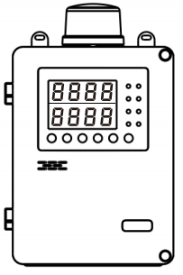
Henan OtywellElectronic Technology Co., Ltd.

Thank you for using the products of our Henan OtywellElectronic Technology Co., Ltd.when you are ready to use this product, please be sure to read this note carefully, and in accordance with the relevant operation steps provided, so that you can fully enjoy the services provided by our company, while avoiding your misoperation and damage to the machine or other accidents.
Please keep this manual safe so that you can consult and get help in time when you need it in the future.
Copyright Notice
The copyright of this manual belongs to Henan Otywell Electronic Technology Co., LTD. Without written permission, any part of this manual shall not be copied, translated, stored in the database or retrieval system, nor shall it be transmitted by any means or means such as electronic, reproduction, recording, etc.
Henan Otywell Electronic Technology Co., Ltd. adhering to the principle of scientific and technological progress, constantly committed to product improvement, improve product performance, the company reserves the right to any product improvement without prior notice.
If the user installs or repairs or replaces the parts without following the instructions in this manual, the user shall be responsible for the resulting damage.
The product, color and style of the product shall be subject to the actual purchase.
User Service Guide
1. Before using this product, please carefully check the accessories, product certificate and user warranty card according to the product factory list. If found incomplete, please contact the seller or manufacturer immediately.
2. Within 12 months from the date of sale of this product, where the user complies with the storage, transportation and use requirements, and the product quality is lower than the technical indicators, with the warranty card to enjoy free maintenance.
3. For damage caused by violation of operating regulations and requirements, failure caused by maintenance not designated by our company's special technical service department or product quality problems caused by irresistible factors, our company will carry out charging maintenance.
4. When the product is repaired, please show the product warranty card. Failure to present the product warranty card will be charged for maintenance.
5. After product maintenance and repair, please show this manual. The maintenance personnel will fill in the attached "Maintenance and repair Record" and sign it; At the same time, please also signon the maintenance and maintenance record of the maintenance personnel to confirm the maintenance and maintenance content and put forward valuable suggestions. For unit users, please affix the official seal.
6. If you have any questions or dissatisfaction with the products and services we provide, including product technology, quality, installation and maintenance, service attitude, charging standards, etc., please contact us in time, we will properly handle your comments.

Company name: Henan Otywell Electronic Technology Co., LTD
Address: Unit 2, Building 38, Liandong U Valley, intersection of Jianyang Road and Lianhua Street, High-tech Zone, Zhengzhou City, Henan Province
Tel: 0371-86189170
Fax: 0371-86628819
Statement:
Combustible gas alarm controller in this manual referred to as: controller

Contents

1.Product Overview 1
2 Main Technical Parameters 2
3.System Function Operation Instructions： 2
4. Mune Function： 4
5.Installation Precautions 9
6.Common Faults and Troubleshooting Methods 10
7.Warranty and Maintenance 10
8.Storage 11
9.Accessories and others 11

Product overview
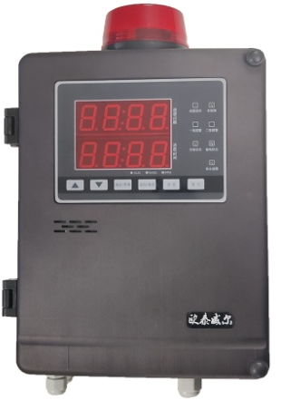
GDB11 Combustible gas alarm controller is a 485 signal output controller developed by our company, which has the characteristics of good stability, high accuracy and intelligent parameter setting. The external control port is rich, the user can freely choose the type of detector and access port, and can carry out on-site monitoring and alarm through simple setting and wiring.

The controller is mainly used in the occasion of monitoring combustible gas, showing the numerical indicator of the gas to be tested. When the indicator of a certain gas to be tested on site does not meet the set standard, the system will automatically carry out a series of alarm actions, such as alarm, exhaust, trip, etc. (according to different Settings of the user).

1.1 The design, manufacture and verification of this product comply with the following national standards:

GB 12358-2024 General technical requirements for environmental gas detection and alarm instrument in workplaces

Main Technical Parameters

☆ Installation mode: wall hanging
☆ Response time: ≤10s
☆ Indication mode: digital tube display, sound and light alarm
☆ Working environment temperature: -10℃ ~ 50℃
☆ Working environment humidity: ≤93%RH
☆ Main power source: AC220V±15%, 50Hz± 1% (main power insurance 3A)
☆ Backup power: one DC12V/1.3AH rechargeable battery (backup power insurance 3A)
☆ Power rate: ≤10W
☆ Detector power supply voltage: DC24V±10%
☆ Communication distance between detector and host: ≤1000m
☆ Number of local channels: 1 loop
☆ Alarm record: ≧1000
☆ Alarm output: 4 groups
☆ Dimensions: L310×W200×H95 mm
☆ Detector and host cable requirements: ≥RVVP 4×1.5mm2

Operation Description of System Functions
3.1 Description of the Detection interface
The controller has two sets of 4-bit nixie tube displays
The normal detection screen is channel 1 and channel 2, and the time is displayed in a cycle.
Alarm interface display: total alarm, first alarm channel, alarm status, alarm time line cyclic display.

CH-1: Channel 1. CH-2: channel 2
ALA: Total number of alarms FIRS: address of the first alarm
ALL: All channels L: low limit alarm H: high limit alarm

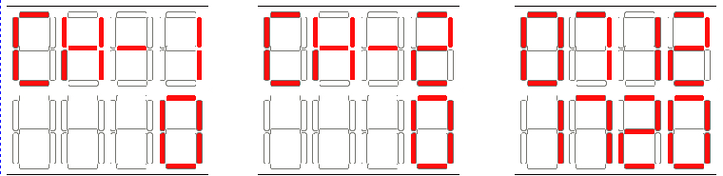
表示通道1 表示通道1 月份/时间

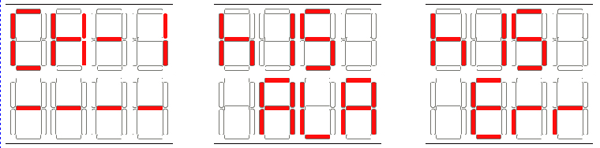
表示通道故障 表示报警记录 表示故障记录

3.2Keydescription:
Up/Down key: Turn the page up and down. (Alarm status interface can be switched)
Query/Return key: Press and hold for 1 second to query historical alarm records.
Mute button: After the alarm sound is issued, press the mute key to eliminate the sound.
Reset button: When the alarm point recovers, press the reset button to return to the normal detection screen. (Password "0000")
3.3 Indicator Description:
Normal main power: Normal operating status indicator Steady green.
Main power failure: After the main power is disconnected, the indicator is steady yellow (after the main power is restored, the indicator is turned off).
Normal backup power: Normal status indicator Steady green.
Backup power failure: After the backup power is disconnected, the indicator is steady yellow (and turns off after the backup power is restored).
Low level alarm: the detector concentration exceeds 20%LEL indicator light is steady red.
Advanced alarm: The detector concentration exceeds 50%LEL indicator light is steady red.
Communication failure: When the detector is disconnected, the indicator is steady yellow.
General fault: When the controller sends any fault signal, the indicator is steady yellow.
Noise suppression indicator: the controller emits an alarm sound, and the indicator light is steady red after noise suppression.

Menu function description:
Note: The controller menu items have passed the factory inspection. If you need to change the key parameters, you are advised to communicate with the manufacturer and do not change them by yourself.
The system uses user login mode to manage operation rights, and users who do not log in to the system can only use the sound suppression function. Press &lt; Menu key &gt; Enter the user "Enter password" interface, tap the "Enter" button on the display, enter the password 1111 Tap "OK" to enter the function setting.
FU-7: Time setting
FU-8: Function self-test (check whether the display function, indicator light and sound are normal)
FU-9: History (historical alarm records can be queried)
Exit menu: Press the query/Return key to exit
Menu | Function | Menu | Function
FU01 | Level One alarm Set | FU05 | zero shift
FU02 | Level 2 Alarm Set | FU07 | System time
FU03 | precision setting | FU08 | function self-test
FU04 | Range | FU09 | history (historical alarm records can be queried)

1. How do I access the menu
In the detection state, press the "Confirm/menu" key to enter the password input interface, the first line of digital tube displays "PASS", the second line of digital tube displays the current password, press ▲ key or press ▼ key to increase or decrease the value, press "Confirm/menu" key to confirm the value, after entering the four-digit password, press "Confirm/menu" key. If the password is correct (1111), the menu is displayed. If the password is incorrect, Err returns to the detection state.
2. How to select functions
After the password is determined to be correct, the first line of the digital tube will display CH01, indicating the first channel. Press the ▲ key or ▼ key to switch between channels (ALL indicates the synchronous setting of all channels). Press "Confirm/Menu" to enter FU01 to indicate function 1, press ▲ or ▼ to select other functions, press "Query/Back" to exit the menu function and return to the channel selection interface.
3, how to set a level alarm value
After entering the FU01 function, 20 is displayed, indicating the low value of the current channel. Press ▲ key or ▼ to increase or decrease the value (or long press ▲ or ▼ key to increase or decrease 10 values), press the "Confirm/menu" key to return the saved data to the function selection directory, or press the "Query/Return" key to return to the function selection directory without saving. (Please confirm the accuracy setting before setting this function)
4. How to set the secondary alarm value
After entering the FU02 function, 50 is displayed, indicating the high value of the current channel, press ▲ key or ▼ key to increase or decrease the value, press "Confirm/menu" key to return the saved data to the function selection directory, or press "Query/Return" key to return to the function selection directory without saving. (Please confirm the accuracy setting before setting this function)
5. How to set the accuracy
After entering the FU03 function, 0,0.0, 0.00, 0.000 will be displayed, indicating the current accuracy value. Press ▲ key or ▼ key to adjust the accuracy value, press "Confirm/Menu" key to return the saved data to the function selection directory, or press "Query/Return" key to return to the function selection directory without saving.
6. How to set the range value
After entering the FU04 function, 100 is displayed, indicating the current range value, press the ▲ key and ▼ key to increase or decrease the value (or long press the ▲ key or ▼ key to increase and decrease 10 values), press the "Confirm/menu" key to return the saved data to the function selection directory, or press the "Query/Return" key to return to the function selection directory without saving. (Please confirm the accuracy setting before setting this function)
7. How to carry out zero shift
After entering the FU05 function, the current zero AD value is displayed. Press the "Confirm/Menu" key to return the saved data to the function selection directory, or press the "Query/Return" key to return to the function selection directory without saving.
8. How to set the time
After entering the FU07 function, display the time, press ▲ key or ▼ key to adjust the time, and "Confirm/Menu" key to switch adjustment parameters. Press "Confirm/Menu" to return the saved data to the function selection directory, or press "Query/Return" to return to the function selection directory without saving the data.
9. System self-test

After entering the FU08 function, all display digital tubes are lit, buzzer sounds, alarm light flashes, and test whether it is normal.

10. Query history

The FU09 function history page is displayed. Press the up or down key to switch between alarm record and fault record. "RLR" indicates alarm record, "Err" indicates fault record. Each alarm information is displayed on three screens. The third screen displays the time and alarm type. "L" indicates first-level alarm, "H" indicates second-level alarm, and "----" indicates fault alarm. If the backup point is used, AC indicates that the main power is faulty, BAT indicates that the backup power is faulty. Press the ▲ key and press the ▼ key to view the previous record and the next record. Detection screen Hold down the Query/Back key for 2s to access the query history screen.
Iv. Wiring instructions
Note the comments below the terminal when wiring


Four-bus controller (with pulse, with backup)
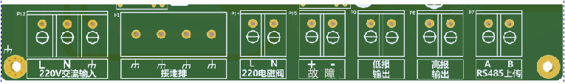
1. The controller has a set of detector wiring points. The wiring terminals on the detector are: VCC positive, GND negative, A, B, 4 wiring positions. To connect with the terminal on the host: positive +, negative -, A, B.
2. The alarm controller has a standard 485 upload port, which can be connected to graphic display devices, computers and other equipment; "A" is the 485 signal +; "B" is the 485 signal - (The wiring sequence must be consistent, otherwise the device communication failure will occur).
3. The alarm controller has two sets of passive switching signal output, low limit alarm output and high limit alarm output.
4. The controller has a set of 220V pulse signal terminal, which can be connected to 220V solenoid valve and other linkage equipment.
5. The controller has a set of fault output terminals. The host is faulty. The fault switch is closed, and the fault signal is output.
6. The controller has a set of 220V power wiring terminals, L live wire, N neutral wire ╧ ground wire.

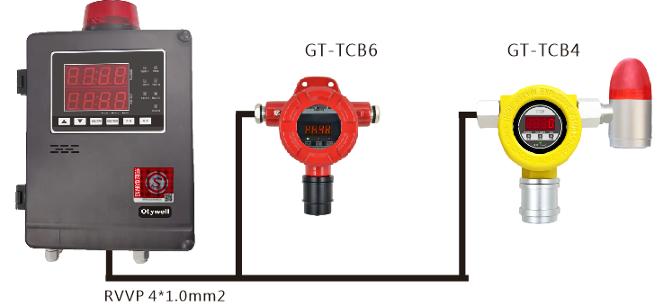

Installation Precautions
1. The controller can not be installed in places with corrosive gas, oil smoke, dust, and frequent rain.
2. Power off the controller before installing the point-type combustible gas detector, and power on the controller after installation.
3. The controller should be installed in the place where someone is on duty and can be handled in time when the alarm is issued.
4. It is recommended that the controller shell be connected to the ground cable to prevent interference with communication.
6. Common faults and troubleshooting methods

1. The system does not respond after power-on. Check whether the system is powered on and whether the indicator on the switching power supply is on.
2. If the startup display is faulty, it means that no detector is connected, or the detector contact line is in poor contact.
After connecting the detector, the detector shows normal, but the controller shows fault, indicating that the detector output signal is faulty. Check whether the output current signal of the detector is normal.

Common faults and troubleshooting methods

1. The system does not respond after power-on. Check whether the system is powered on and whether the indicator on the switching power supply is on.
2. If the startup display is faulty, it means that no detector is connected, or the detector contact line is in poor contact.
3. After connecting the detector, the detector shows normal, but the controller shows fault, indicating that the detector output signal is faulty. Check whether the output current signal of the detector is normal.

Warranty and Maintenance
(1) This product warranty period of one year, normal use of failure, you can enjoy free factory repair, maintenance services. The damage caused by man-made and natural disasters and improper use is not covered by the warranty.
(2) If the user can not troubleshoot, send back to our company for maintenance, we will troubleshoot and return to the user at the fastest speed.
(3) If the problem cannot be solved, or if the zero point drifts after long-term use and other problems, please contact the company, the company will provide solutions according to the specific situation.

Storage
The controller should be stored in a ventilated room where the ambient temperature is0℃～55℃and the relative humidity is not greater than 85%, and the air must not contain harmful gases or impurities that corrode the controller.

Accessories and Others
The supporting controller is provided with one carton, one controller, one manual, one warranty card, one mounting plate, one bag of installation accessories for waterproof joints, and two keys. The controller has been inspected and issued a certificate before leaving the factory. If it is damaged during transportation, the manufacturer is responsible for replacing it.

