Gas Alarm Controller
GDB15

Instruction Manual

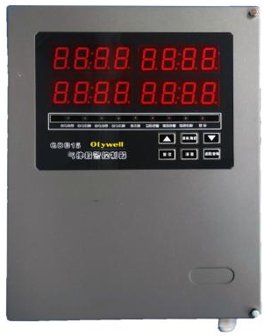
Henan Otywell Electronic Technology Co., Ltd.

Thank you for using the products of our Henan Otywell Electronic Technology Co., Ltd. when you are ready to use this product, please be sure to read this note carefully, and in accordance with the relevant operation steps provided, so that you can fully enjoy the services provided by our company, while avoiding your misoperation and damage to the machine or other accidents.
Please keep this manual safe so that you can consult and get help in time when you need it in the future.
Copyright Notice
The copyright of this manual belongs to Henan Otywell Electronic Technology Co., LTD. Without written permission, any part of this manual shall not be copied, translated, stored in the database or retrieval system, nor shall it be transmitted by any means or means such as electronic, reproduction, recording, etc.
Henan Otywell Electronic Technology Co., Ltd. adhering to the principle of scientific and technological progress, constantly committed to product improvement, improve product performance, the company reserves the right to any product improvement without prior notice.
If the user installs or repairs or replaces the parts without following the instructions in this manual, the user shall be responsible for the resulting damage.
The product, color and style of the product shall be subject to the actual purchase.
User Service Guide
1. Before using this product, please carefully check the accessories, product certificate and user warranty card according to the product factory list. If found incomplete, please contact the seller or manufacturer immediately.
2. Within 12 months from the date of sale of this product, where the user complies with the storage, transportation and use requirements, and the product quality is lower than the technical indicators, with the warranty card to enjoy free maintenance.
3. For damage caused by violation of operating regulations and requirements, failure caused by maintenance not designated by our company's special technical service department or product quality problems caused by irresistible factors, our company will carry out charging maintenance.
4. When the product is repaired, please show the product warranty card. Failure to present the product warranty card will be charged for maintenance.
5. After product maintenance and repair, please show this manual. The maintenance personnel will fill in the attached "Maintenance and repair Record" and sign it; At the same time, please also sign on the maintenance and maintenance record of the maintenance personnel to confirm the maintenance and maintenance content and put forward valuable suggestions. For unit users, please affix the official seal.
6. If you have any questions or dissatisfaction with the products and services we provide, including product technology, quality, installation and maintenance, service attitude, charging standards, etc., please contact us in time, we will properly handle your comments.

Company name: Henan Otywell Electronic Technology Co., LTD
Address: Unit 2, Building 38, Liandong U Valley, intersection of Jianyang Road and Lianhua Street, High-tech Zone, Zhengzhou City, Henan Province
Tel: 0371-86189170
Fax: 0371-86628819

Declaration: The combustible gas alarm controller is referred to as "controller" in this manual

Content

1. Product Overview
2. Main Technical Parameters
3. Operation Description of System Functions
3.1 Description of the Detection Interface
3.2 Key Description
3.3 Indicator Description
3.4 Menu Function Description
3.5 Description of Wiring Terminals
4 Installation Precautions
5 Common Faults and Solutions
6 Warranty and Maintenance
7 Storage
8 Accessories

Product Overview

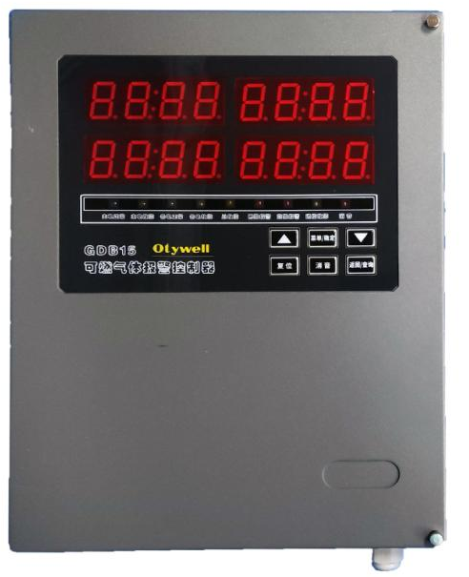
GDB15 gas alarm controller is a 485 output signal controller developed by our company, which has the characteristics of good stability, high accuracy and intelligent parameter setting. The external control port is rich, the user can freely choose the type of detector and access port, and can carry out on-site monitoring and alarm through simple setting and wiring.

The controller is mainly used in the occasion of monitoring combustible gas, showing the numerical indicator of the gas to be tested. When the indicator of a certain gas to be tested on site does not meet the set standard, the system will automatically carry out a series of alarm actions, such as alarm, exhaust, trip, etc. (according to different Settings of the user).

1.1 The design, manufacture and verification of this product comply with the following national standards:
GB 12358-2024 General technical requirements for environmental gas detection and alarm instrument in workplaces

Main Technical Parameters
-  Mounting mode: Wall mounted
-  Indicating mode: digital tube display, sound and light alarm
-  Operating temperature: -10℃ ~ 50℃
-  Working humidity: （20 ~ 93）%RH
-  Main power supply: AC220V±15%, 50Hz± 1% (main power insurance 3A)
-  Backup power supply: two DC12V/1.3AH rechargeable batteries in series (backup power insurance 3A)
-  Power rate: ≤10W
-  Detector supply voltage: DC24V（1±15%）
-  Dimensions: L295×W226×H86 mm
-  Cable between the detector and the host: ≥RVVP 4 x 1.5mm²
-  Communication distance between the detector and the host: ≤1000m
-  Number of local channels: 1 Detector loop
-  Alarm record: ≤3000
-  Alarm output: 2 groups

The machine can receive the instrument type: after the alarm of the point type combustible gas detector with the output signal of 485, the audible and visual alarm signal can be issued, and it can be kept until the alarm sound signal can be manually reset

Operation Description of System Functions
3.1 Description of the Detection interface
The controller has four sets of 4-bit nixie tube displays
The normal detection screen is channel 1 and channel 2, and the time is displayed in a cycle.
Alarm interface display: total alarm, first alarm channel, alarm status, alarm time line cyclic display.
CH-1: indicates channel one
CH-2: indicates channel two
ALA: Total number of alarms
FIRS: first report address
ALL: indicates all channels
L: Low alarm
H: High limit alarm alarm
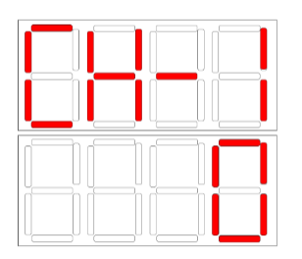
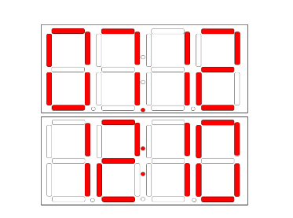
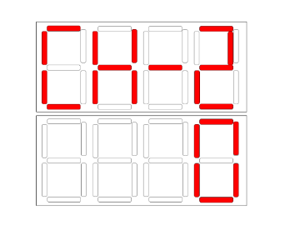

月份/时间

表示通道2

表示通道1

3.2 Key Description:
Menu/Confirm button: Enter the menu button. (Password "1111")
Up/Down key: Turn the page up and down. (Alarm status interface can be switched)
Query/Return key: Press and hold for 1 second to query historical alarm records.
Mute button: After the alarm sound is issued, press the mute key to eliminate the sound.
Reset button: When the alarm point recovers, press the reset button to return to the normal detection screen. (Password "2222")
3.3 Indicator Description:
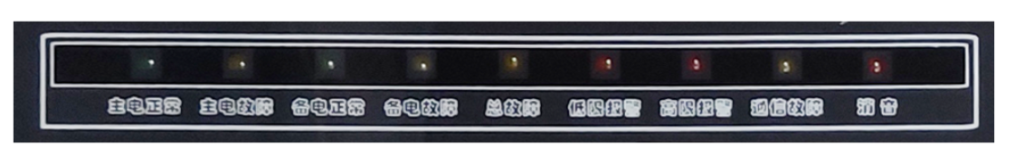

Normal main power: Normal operating status indicator Steady green.
Main power failure: After the main power is disconnected, the indicator is steady yellow (after the main power is restored, the indicator is turned off).
Normal backup power: Normal status indicator Steady green.
Backup power failure: After the backup power is disconnected, the indicator is steady yellow (and turns off after the backup power is restored).
Low level alarm: the detector concentration exceeds 20%LEL indicator light is steady red.
Advanced alarm: The detector concentration exceeds 50%LEL indicator light is steady red.
Communication failure: When the detector is disconnected, the indicator is steady yellow.
General fault: When the controller sends any fault signal, the indicator is steady yellow.
Noise suppression indicator: the controller emits an alarm sound, and the indicator light is steady red after noise suppression.
3.4 Menu Function Description:
Note: The controller menu items have passed the factory inspection. If you need to change the key parameters, you are advised to communicate with the manufacturer and do not change them by yourself.

The system uses user login mode to manage operation rights, and users who do not log in to the system can only use the sound suppression function. Press &lt; Menu key &gt; Enter the user "Enter password" interface, tap the "Enter" button on the display, enter the password 1111 Tap "OK" to enter the function setting.

FU-7: Time setting
FU-8: Function self-test (check whether the display function, indicator light and sound are normal)
FU-9: History (historical alarm records can be queried)
Exit menu: Press the query/Return key to exit
3.5 Description of Wiring terminals
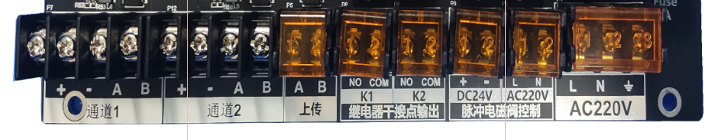

1. Channel 1 is the combustible gas detector 485 signal input terminal, and + "is the positive terminal of the controller; "-" indicates the negative terminal of the controller, and "A" indicates the 485 signal. B indicates the 485 signal. (The wiring sequence of controllers must be consistent; otherwise, controller faults may occur.)

2. Channel 2 is 4G upload port, which can connect to 4G module; "+" positive terminal; "-" negative terminal, "A" 485 signal +; "B" is the 485 signal -(the wiring sequence of the controller must be consistent with the detector, otherwise the controller communication failure will be caused).

3. The alarm controller has a standard 485 upload port, which can be connected to graphic display devices, computers and other equipment; "A" is the 485 signal +; "B" is the 485 signal - (The wiring sequence must be consistent, otherwise the device communication failure will occur).

4. The alarm controller has two sets of passive switching signal output, K1 low limit alarm output, K2 high limit alarm output.

5. The controller office has a set of 220V pulse signal terminals that can be connected to linkage devices such as 220V solenoid valves.

6. The controller has a set of fault output terminals. The host is faulty. The fault switch is closed, and the fault signal is output.

7. The controller office has a set of 220V power wiring terminals, consisting of live wire and neutral wire ╧ ground wire.

Installation Precautions

1. The controller can not be installed in places with corrosive gas, oil smoke, dust, and frequent rain.
2. Power off the controller before installing the point-type combustible gas detector, and power on the controller after installation.
3. The controller should be installed in the place where someone is on duty and can be handled in time when the alarm is issued.
4. It is recommended that the controller shell be connected to the ground cable to prevent interference with communication.

Common Faults and Solutions
(1) The system does not respond after power-on. Check whether the system is powered on and whether the indicator on the switching power supply is on.
(2) If the startup shows a fault, it means that there is no access to the detector, or the detector contact line is in poor contact.
(3) After connecting the detector, the detector shows normal, but the controller shows fault, indicating that the detector output signal is faulty. Check whether the output current signal of the detector is normal.

Warranty and Maintenance
(1) This product warranty period of one year, normal use of failure, you can enjoy free factory repair, maintenance services. The damage caused by man-made and natural disasters and improper use is not covered by the warranty.
(2) If the user can not troubleshoot, send back to our company for maintenance, we will troubleshoot and return to the user at the fastest speed.
(3) If the problem cannot be solved, or if the zero point drifts after long-term use and other problems, please contact the company, the company will provide solutions according to the specific situation.

Storage
The controller should be stored in a ventilated room where the ambient temperature is 0℃～55℃ and the relative humidity is not greater than 85%, and the air must not contain harmful gases or impurities that corrode the controller.

Accessories
The supporting controller is provided with one carton, one controller, one manual, one warranty card, one mounting plate, one bag of installation accessories for waterproof joints, and two keys.

