Portable Gas Detection and Alarm Instrument
(Pump-suction multi-gas detector)
OT135
operating instruction

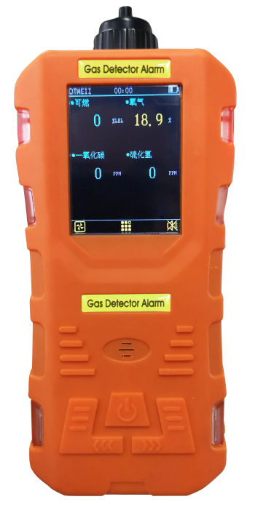

Henan Outewell Electronic Technology Co., Ltd.
ISO9001 Quality Management System Certified Enterprise

Thank you for using Henan Outeiwei product series. Before using this product, please carefully read the instructions and follow the provided operational steps to fully utilize our services while avoiding potential damage to the device or other accidents caused by improper operation.
Please keep this manual properly for easy reference and assistance when needed in the future.

Copyright Statement
This manual is copyrighted by Henan Outeiwei Company. Without written permission, no part of this manual may be reproduced, translated, stored in databases or retrieval systems, or disseminated through any means or methods such as electronic transmission, photocopying, or audio recording.
Henan Outewell Company adheres to the principle of technological advancement, continuously striving for product improvement and performance enhancement. The company reserves the right to make any product modifications without prior notice.
If users install, repair, or replace components without following the instructions in this manual, they shall bear all resulting liabilities.

User Service Guide
- Before using this product, please carefully verify that all attachments, product certification, and user warranty card are complete according to the factory list. If any items are missing, contact the seller or manufacturer immediately.
- For products sold within twelve months from the date of sale, if the product quality falls below the technical specifications while users comply with storage, transportation, and usage requirements, free repairs will be provided upon presentation of the warranty certificate.
- For damages caused by violations of operational regulations and requirements, malfunctions not repaired by the designated authorized technical service department, or product quality issues resulting from force majeure factors, our company will charge for repair services.
4 When repairing the product, please present the product warranty card proactively. Failure to provide the warranty card will result in charged repairs.
5. After product maintenance or repair, please present this manual. The maintenance personnel will fill out and sign the attached "Maintenance and Repair Record." Additionally, please sign the maintenance personnel's "Maintenance and Repair Record" to confirm the maintenance/repair details and provide valuable feedback. For institutional users, please affix the official seal.
6 If you have any questions or concerns regarding our products and services—including technical specifications, quality standards, installation and maintenance, service attitude, or pricing—we kindly ask you to contact us promptly. Your feedback will be addressed with due consideration.

catalogue
I. Overview 1 5
II. Main Technical Specifications 2 6
III. Product Appearance, Functionality, and Instructions 3 6
IV. Product Operation Instructions 3 7
V. Precautions for Use 9 13
VI. Common Faults and Their Solutions 10 14
VII. Warranty and Maintenance 11 15
VIII. Storage 11 15
IX. Accessories 11 15

Usage Instructions
Before using the detector, please read the following precautions.
- Before using the detector, inspect the housing for cracks or missing parts. If the detector is damaged or has missing parts, contact our company or dealer immediately.
- Self-replacing components may compromise the internal safety of the detector.
- Gas detectors must not be exposed to electric shock or severe continuous mechanical vibration environments.
- Discarded batteries and sensors should be disposed of by qualified recyclers or hazardous waste handlers, and must not be thrown into trash bins indiscriminately.
- Do not disassemble batteries or place them in fire, and avoid short circuits between the positive and negative terminals, as this may cause fires or explosions.
- Do not disassemble, adjust, or repair this gas detector without authorization.
- Do not splash water, chemical solvents, benzene, or gasoline onto the detector, and avoid inhalation of such substances, as this may cause malfunction of the detector.
- Protect the device from falling from a height or experiencing severe vibrations.
- To ensure the measurement accuracy of the detector, regular calibration (at least annually) is required.
- Artificial frequent exposure of the detector to high-concentration toxic gases should be avoided.
- Continue use is prohibited when the sensor has failed or exceeded its service life.
- Before using this instrument, please carefully read the instruction manual and strictly follow the procedures outlined therein.
- For any applications beyond those described in this manual or for usage-related issues, please contact the distributor or manufacturer for assistance.

I. Overview
The OT135 Portable Pump-Suction Gas Detector is an intrinsically safe instrument capable of continuous monitoring of multiple gas concentrations. It supports up to 7 configurable gas detection modes with flexible combination options tailored to operational needs. Designed for explosion-proof environments, this device proves essential for gas leak emergency response in underground pipelines and similar hazardous settings, effectively safeguarding personnel lives while preventing equipment damage.
The instrument employs a pump suction detection principle, with sensors utilizing imported components that exhibit excellent sensitivity and outstanding repeatability. It features embedded microcomputer control for simplified operation. The detector housing is constructed from high-strength engineering plastic combined with anti-slip rubber, ensuring high durability, comfortable handling, as well as water resistance, dust resistance, and explosion-proof properties.
1.1 The design, manufacture, and verification of this product comply with the following national standards
GB/T 3836.1—2021 Explosive Atmospheres Part 1: Equipment General Requirements
GB/T 3836.4—2021 Explosive Atmospheres Part 4: Equipment Protected by Intrinsically Safe Type 'i' Protection
GB 12358—2024 Environmental Gas Detection and Alarm Instruments for Workplace-General Technical Requirements
GB/T 4208—2017 Enclosure Protection Rating (IP Code)
JJG 693—2011 Flammable Gas Detector and Alarm Device
JJG 915—2008 Carbon Monoxide Detection and Alarm Device
1.2 Main Functions and Features of the Product
◆ Equipped with a 2.4-inch high-definition full-color IPS industrial display with wide viewing angle
◆ Display various technical indicators and gas concentration values
◆ High-performance imported sensor
◆ Capable of simultaneously detecting 1-4 gases with flexible sensor combinations
◆ Features data storage capability, supporting up to 1,000 data entries
◆ Dustproof, explosion-proof, and waterproof design
◆ Intrinsically safe circuit design, anti-static and electromagnetic interference protection
◆ Optional sampling probe rod and its catheter
◆ Built-in high-power carbon membrane self-priming pump with extremely fast response time
◆ Adjustable settings for time and alarm functions

II. Main Technical Specifications
- Suitable gases: combustible/toxic/hazardous gases/oxygen, etc.
- Detection principles: catalytic combustion type, electrochemical type, infrared type, laser type, semiconductor type, etc.
- Detection method: Built-in pump suction type
- Measurement range: (0–100)%LEL (flammable); (0–100)µmol/mol (toxic), etc. (depending on gas type)
- Resolution: 1% LEL, 1 µmol/mol, 0.1 µmol/mol/%VOL
- Accuracy grade: ±3%FS (flammable/oxygen); ±5%FS (toxic)
- Lower limit alarm setting: 20% LEL (flammable)
- Upper limit alarm setpoint: 50% LEL (flammable)
- Display mode: LCD
- Response time: ≤30s
- Environmental temperature: -25°C to +55°C
- Relative humidity: (20～93)%
- Power supply voltage: DC 3.7 V
- Battery capacity: 1800 mAh + 1300 mAh lithium-ion rechargeable battery
- Charging time: <5 h
- Standby time: ≥8 h
- Pressure limit: 86 kPa to 106 kPa
- Product dimensions: L 164 mm × W 78 mm × H 50 mm
- Product weight: approximately 400 g
- Standard hose: 60 cm
- Explosion-proof certificate number: CLEx24.1024
- Explosion-proof rating: Ex ia ⅡC T4 Ga; Ex ib ⅢC T130℃ Db
- Protection rating: IP65
- Mark and number of type approval certificate for measuring instruments: (CH4, CO)

III. Product Appearance, Functionality, and Indications
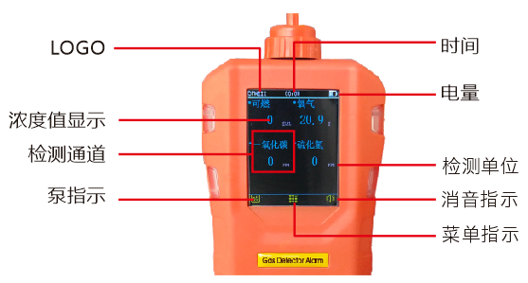
Product display interface description
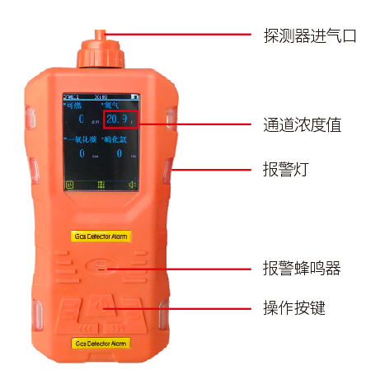
Product overall structure diagram

IV. Product Operation Instructions

4.1 Product Startup Instructions
When the device is powered off, pressing the button for more than 2 seconds activates the detector. The system then automatically executes the following self-check procedure:
1. System display; Welcome interface.
2. Emit a startup sound to test the buzzer function. Activate vibration, suction pump, and audible alarm indicators to verify the normal operation of each function.
3. Display high and low readings for each detection channel, detection range, and after the self-check procedure is completed, directly enter normal detection mode. As shown in the figure:
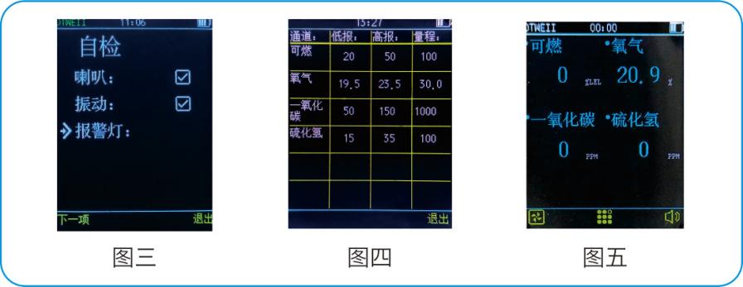
4.2 Product Shutdown Instructions
Press the button while the device is powered on and operating in detection mode. The buzzer will emit intermittent sounds accompanied by vibration and visual alerts. After 3 seconds, the information will disappear, and releasing the button will turn off the device.
4.3 Product Parameter Function Description

The parameter sets the default password to 1111. If no password is set, the system will return to the detection interface after 10 seconds.
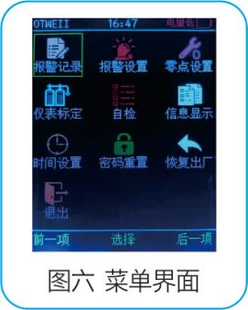
See the table below for user menu function descriptions
Alarm history: View recent alarm records
Alarm settings: You can configure low-level and high-level alarm thresholds for each detection channel.
Zero point setting: You can adjust the zero point offset for each detection channel.
Instrument calibration: Gas parameters of each channel can be verified or calibrated using sample gas.
Self-test: Can detect whether various instrument indicators are normal
The information shows: you can visually view parameters such as alarm range for each channel.
Time settings: Set alarm time
Password reset: You can set a login password to prevent accidental access from other sources.
Restore factory settings: You can directly restore the device to its factory configuration. Original data will be automatically deleted after restoration. Proceed with caution.
Exit: This function allows you to return directly to the detection interface or automatically return after 10 seconds if no further actions are performed.
Warning: Charging the detector while powered on may compromise the accuracy of detection data. Do not charge the detector at the detection site to avoid potential fires or explosions caused by sparks from unplugging the charger. Additionally, refrain from charging the detector while it is powered on to prevent reduced charging speed and shortened battery life.
4.4 Product Alarm Indicator Description
Low alarm
· Slowly modulating beeping alarm sound · Slow flashing alarm indicator light · Vibration
High alarm
·Rapid pitch-changing beeping alarm sound ·Alarming indicator light flashing rapidly ·Vibration
4.5 Product Operation Instructions
1. Alarm record: Records alarm data.
- Press the middle key directly to enter the menu and select the first item "Alarm Record". Click the middle key again to access the "Alarm Record Menu" as shown in the figure.
- Click the "Middle Key" to select and enter the "Clear/Exit" function. As shown in Figure 1-2.
- Click the left button to clear alarm records. As shown in Figure 1-3. Confirm whether to clear alarm records and click the left button again to clear them. As shown in Figure 1-4. Click the right button to return to the menu.
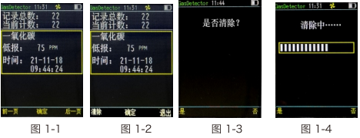
2. Alarm settings: Set the low and high alarm thresholds for the channel.
- Select 'Alarm Settings' from the menu items to enter the alarm settings interface. As shown in Figure 2-1, press the left/right buttons to switch between channels 'Previous Item' and 'Next Item'.
- Press the middle key to adjust the selection box position vertically (see Figure 2-2). Press the left or right keys to "increase" or "decrease" the preset height values.
- Move the selection box to the bottom, right-click and select "Save" to display the save icon. As shown in Figure 2-3, the save is successful. Right-click "Exit" to return to the menu interface. Press the middle key "Select" to switch channels.
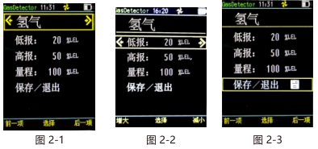
3. Zero point setting: When entering zero point adjustment mode, the air pump will automatically activate.
- Press the left or right arrow keys to switch between the "Previous" and "Next" selection channels. See Figure 3-1.
- Press the left or right arrow keys to switch between the "Previous" and "Next" selection channels. See Figure 3-1.
- Move the selection box to the bottom, wait for the zero point value to stabilize, then click the left button to select "Save" and the save icon will appear. As shown in Figure 3-3, this indicates successful saving. Click the right button to "Exit" and return to the menu interface. Press the middle button to "Select" to switch channels.
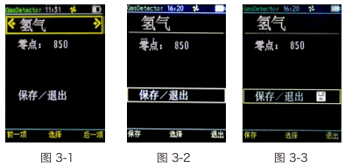
4. Instrument Calibration: Upon entering calibration mode, the air pump will automatically activate.
- Press the left or right arrow keys to switch between the "Previous" and "Next" channels. As shown in Figure 4-1, after selection, proceed to zero point translation. See Figure 4-2.
- Save the zero point by clicking 'Save' with the left mouse button. (Note: When saving zero point values, ensure the operation is performed in clean air.)
- Enter the standard gas password (9119) using the middle key "Standard Gas" to access the standard gas interface. As shown in Figure 4-3.
- Press the left or right arrow keys to enter standard gas values. See Figure 4-4
- The intermediate key "Ventilation" is activated to initiate ventilation calibration. Wait for the values to stabilize (this process should not exceed 60 seconds), then click the left key "Save" to store the ventilation values. As shown in Figure 4-5.
- After successful saving, the save icon will appear. Right-click to select Exit and return to the menu, or click the middle button Select to switch channels.
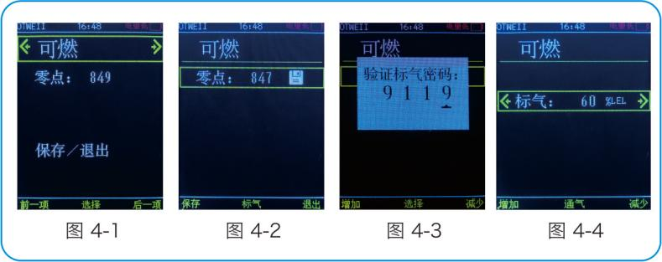
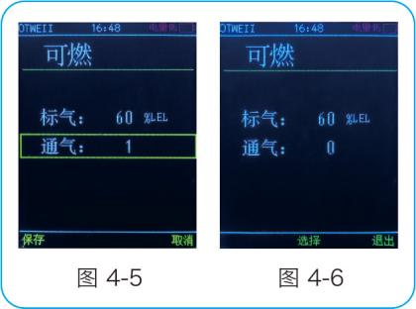
5. Self-check: Check the speaker, vibration, and buzzer. Refer to Figure 5-1.
- Press the left button to quickly navigate to the next item, or right-click "Exit" to return to the menu.
6. Information display: Shows information for each channel. See Figure 6-1
7. Time setting: Set according to the specified time. See Figure 7-1.
- Press the middle key "Select" to switch years, months, days, hours, minutes, and seconds. Press the left and right keys "Increase" and "Decrease" to adjust the time.
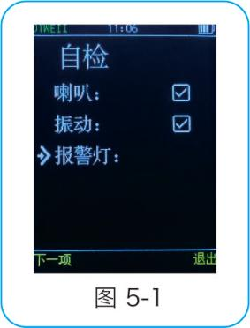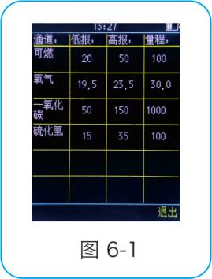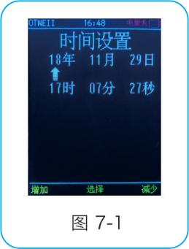
8. Password reset: Change user password
- First, verify the user's original password. See Figure 8-1
- After verification, proceed to password modification as shown in Figure 8-2. Use the left/right buttons to adjust the value by pressing "Increase" or "Decrease".
- After entering and confirming the password, you will be prompted to save it. Left-click "Yes" to save the password and complete the modification. Return to the menu item and right-click "No" to cancel saving and return to the menu.
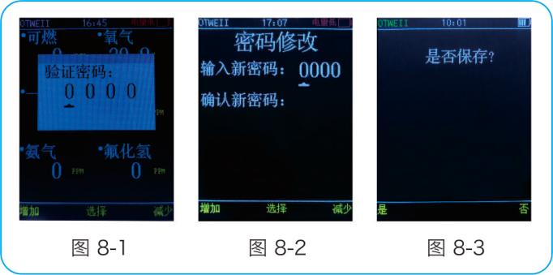
9. Restore factory settings: Reset data to factory defaults.
- Verify the user password first.
- Prompt whether to restore. See Figure 9-1
- Click Yes with the left mouse button to start recovery. See Figure 9-2. After recovery, return to the menu.
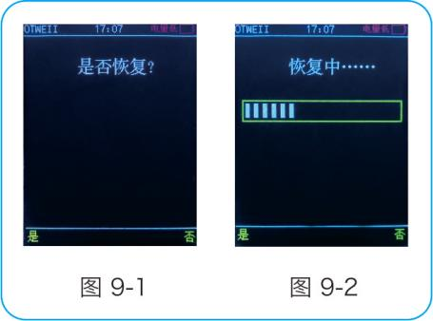

V. Precautions for Use
(1) Prevent the device from falling from a height or experiencing severe vibration.
(2) The device may not function properly in the presence of high-concentration gases.
(3) Please strictly follow the instructions for operation and use; otherwise, it may lead to inaccurate test results or damage to the device.
(4) This product shall not be stored or used in environments containing corrosive gases (such as high concentrations of chlorine gas), nor shall it be used or stored under other harsh conditions (including extreme temperatures, high humidity, electromagnetic fields, or intense sunlight).
(5) If the surface of this device becomes contaminated after prolonged use, gently wipe it with a clean soft cloth dampened with water. Avoid using corrosive solvents or hard objects for cleaning, as this may cause scratches or damage to the device surface.
(6) To ensure detection accuracy, this device shall undergo periodic calibration, with the verification cycle not exceeding one year.
(7) It is recommended that infrared sensors and semiconductor sensors have a service life of 5 years, while catalytic combustion sensors and electrochemical sensors have a service life of 2 years.
(8) Please remove the lithium battery and sensors from the discarded detector and deliver them to the designated location or return them to our company. Do not dispose of them in trash bins indiscriminately.
(9) For any applications or usage issues beyond those described in this manual, please contact our company for assistance.
(10) Battery packs must not be disassembled or replaced, nor charged in explosive gas environments. Peripheral plug-in devices without explosion-proof certification must not be used, and sensors must not be replaced in such environments.
(11) Products with explosion-proof certification shall not be arbitrarily replaced or modified with components or structures that affect their explosion-proof performance.
(12) Relevant national standards contain explicit regulations on the selection, installation, or use of electrical equipment in explosion-hazardous environments. Installation or user entities must strictly comply with these provisions to ensure explosion-proof safety of electrical equipment in such areas.
(13) Charging must be performed in a safe location and using the professional charger provided with this device.
(14) If the suction force of the built-in pump suction sampling pump is insufficient, loosen the sampling air intake cover at the top of the product and inspect the internal filter screen. When the filter screen is dirty, clean or replace it promptly, then re-tighten the air intake cover after completion. Figures 5-1 and 5-2 respectively show comparative images of clean and dust-accumulated filter screens.
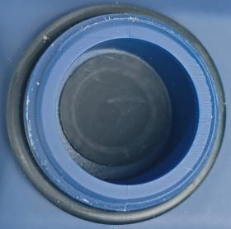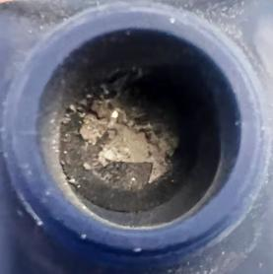
Figure 5-1 Figure 5-2 Figure 5-1 Figure 5-2

VI. Common Faults and Their Solutions
fault phenomenon | Possible cause of failure | process mode
Cannot boot | voltage below level | Charge your device promptly
Cannot boot | system halted | Contact the dealer or manufacturer for repair
Cannot boot | fault | Contact the dealer or manufacturer for repair
No reaction to the detected gas | Circuit failure or sensor lifespan expired | Contact the dealer or manufacturer for repair
Display is inaccurate | Sensor expired | Contact the dealer or manufacturer to replace the sensor.
Display is inaccurate | Long-term uncalibrated | Calibrate promptly
Time display error | The battery is completely drained | Charge promptly and reset the time
Time display error | strong electromagnetic interference | Reset time
Zero calibration is unavailable | Excessive sensor drift | Calibrate or replace the sensor promptly
Display non-zero values in clean air environments | Sensor drift | Perform zero calibration
The instrument's normal detection interface displays full range indication | Sensor failure | Contact the dealer or manufacturer to replace the sensor.

VII. Warranty and Maintenance
(1) This product is covered by a one-year warranty (excluding wear parts). In case of malfunction under normal usage conditions, free factory repair and maintenance services are provided. Damage caused by human error, natural disasters, or improper use is not covered by the warranty.
(2) If the sensor reaches its end of life, please contact our company for replacement.
(3) If the user cannot resolve the issue, the detector may be returned to our company for repair. We will promptly troubleshoot and deliver it back to the user.

VIII. Storage
The product shall be stored in a ventilated room with an ambient temperature ranging from-10°C to +55°C and relative humidity not exceeding 85%, and the air must be free from harmful gases or impurities that may cause corrosion to the product.

IX. Accessories
The accompanying products include one portable gas detection alarm device, one user manual, one product qualification certificate and warranty card, one factory inspection report, and one set of chargers.



Henan Otywell Electronic Technology Co., Ltd.

Address: Unit 2, Building 38, Lian Dong U Valley, Lianhua Street, High-tech Zone, Zhengzhou City, Henan Province
Phone: 400-811-8873
Website: http://www.otywell.com

