Portable Gas Detection and Alarm Instrument
OT139
operating instruction

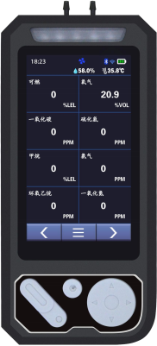

Henan Outaiwei Electronic Technology Co., Ltd. is an ISO9001 Quality Management System certified enterprise.

Thank you for using the product series from Henan Outewell Electronic Technology Co., Ltd. Before using this product, please carefully read these instructions and follow the provided operational steps to fully utilize our services while avoiding accidental damage to the device or other incidents due to improper operation.

Copyright Statement
Henan Outaiwei Electronic Technology Co., Ltd. adheres to the principle of technological advancement, continuously striving for product improvements and performance enhancements. The company reserves the right to make any product modifications without prior notice.
If the user installs, repairs, or replaces components without following the instructions in this manual, the user shall be responsible for any resulting liabilities.

User Service Guide
1 Before using this product, please carefully verify the completeness of accessories, product certification, and user warranty card according to the factory list. If any deficiencies are found, immediately contact the seller or manufacturer.
2 For this product, within twelve months from the date of sale, if the user complies with storage, transportation, and usage requirements but the product quality falls below the technical specifications, free repair will be provided upon presentation of the warranty certificate.
3 For damages caused by violation of operational regulations and requirements, malfunctions not repaired by the designated authorized technical service department of our company, or product quality issues resulting from force majeure factors, our company will charge for repair services.
4 When undergoing maintenance, please proactively present the product warranty card. Failure to present the warranty card will result in charged repairs.
5. After product maintenance or repair, please present this manual. The maintenance personnel will fill out and sign the attached "Maintenance and Repair Status Record." Additionally, please sign the record to confirm the maintenance/repair details and provide valuable feedback. For institutional users, please affix the official seal.
6. If you have any questions or concerns regarding our products and services—including technical specifications, quality, installation and maintenance, service attitude, or pricing—we kindly ask you to contact us promptly. Your feedback will be addressed with due care.
Warning: Charging detectors or opening covers while powered on at the work site is strictly prohibited.

catalogue

I. Overview 1 1

II. Main Technical Specifications 2 2

III. Natural Appearance and Functional Indications 3 3

IV. Operating Instructions 4 4

1. Channel Settings 6 6
2. Time Setting 6 6
3. Police report records 7 7
4. Zero Point Setting 7 7
5. Calibration 8 8
6. Restore factory settings 8 8
7. Upload Settings 9 9

V. Precautions 9 9

VI. Common Faults and Their Solutions 10 10

VII. Storage 11 11

VIII. Accessories 11 11

Usage Instructions

Before using the detector, please read the following precautions.
Damaged gas detectors must not be used. Before operation, inspect the housing for cracks or missing components. If the detector is damaged or has missing parts, contact our company or authorized dealer immediately.
Self-replacement of components may compromise the internal safety of the detector.
Gas detectors must not be exposed to electric shock or severe continuous mechanical vibration environments.
Discarded batteries and sensors should be disposed of by qualified recyclers or hazardous waste handlers, and must not be thrown into trash bins indiscriminately.
Do not disassemble batteries or place them in fire, and avoid short circuits between the positive and negative terminals, as this may cause fires or explosions.
Unauthorized disassembly, adjustment, or repair of this gas detector is prohibited.
Do not splash water, chemical solvents, benzene, or gasoline onto the detector, and avoid inhalation of such substances, as this may cause malfunction of the detector.
Prevent the device from falling from a height or experiencing severe vibrations
To ensure the measurement accuracy of the detector, regular calibration of the detector (at least annually) is required.
Artificial frequent exposure of the detector to high-concentration toxic gases should be avoided.
The sensor must not be used further if it has failed or exceeded its service life.
Before using this instrument, please carefully read the instruction manual and strictly follow the procedures outlined therein.
For any applications beyond those described in this manual or for usage-related issues, please contact the distributor or manufacturer for assistance.

I. Overview
The OT139 is a high-sensitivity industrial portable multi-gas detection instrument designed for explosion-proof environments, including gas leak emergency response scenarios and underground pipeline systems in mines. It effectively safeguards personnel safety and prevents equipment damage. Primarily used for detecting pipeline gas leaks, the device can identify various gases depending on sensor types. Featuring compact dimensions, user-friendly operation, and excellent portability, it offers superior vibration resistance. Equipped with high-resolution dot-matrix LCD display technology, the product delivers intuitive and crystal-clear visual presentation.
It is suitable for areas containing explosive gas mixtures of Zone 1 and Zone 2 with Class IA and Class IB. Dustproof enclosures are used for Zones 21 and 22.
1.1 The design, manufacture, and verification of this product comply with the following national standards
GB/T 3836.1-2021 Explosive Atmospheres Part 1: Equipment General Requirements
GB/T 3836.4-2021 Explosive Atmospheres Part 4: Equipment Protected by Intrinsically Safe Type "i" Protection GB/T 4208-2017 Enclosure Protection Classification (IP Code)
GB 12358—2024 Environmental Gas Detection and Alarm Instruments for Workplace-General Technical Requirements

1.2 Model Description
The detector model and code meanings are as follows:
OT 139


Design Serial Number Product Type

OT139, where OT denotes the product form indicating a portable gas detector; 139 is the design serial number indicating a multi-gas combination configuration.
1.3 Main Functions and Features
1. Large-screen color Chinese display
2. Capacitive touch + button operation
3. Rapid detection of gas leakage points
4. Data uploads to the cloud in real time
5. Low voltage indication and automatic shutdown upon undervoltage
6. Sensor fault detection and startup self-check function
7. Rapid preheating with swift response time

8. Acoustic vibration alarm signal
9. Convenient zero-point adjustment for quick and easy operation
10. Can detect up to eight gases in free combination

II. Main Technical Specifications
Detectable gases: combustible gases/toxic and harmful gases/O2
Measurement range: (3–100)%LEL (flammable); (0–100)µmol/mol (toxic) (multiple ranges available)
Accuracy grade: ± 3%FS (flammable); ± 5 µmol/mol or ±10% (toxic) (depending on the specific gas)
Lower limit alarm setpoint: 20% LEL (flammable)
Response time: ≤ 30s
Repeatability: ≤ 2%
Detection method: Pump suction type
Detection principle: Catalytic combustion type; Electrochemical type
Power supply voltage: DC7.4V
Battery model: FRT-FB182S01C
Battery capacity: 3000mAh lithium-ion rechargeable battery
Environmental temperature: -10°C to 55°C
Relative humidity: (20～93)% (no condensation)
Preheating time: ≤ 30s
Display method: LCD color liquid crystal display
Charging time: less than 5 hours
Continuous operating time: no less than 12 hours
Explosion-proof certificate number: CNEx23.1393X
Explosion-proof rating: Ex ib ⅡB T4 Gb / Ex ib ⅢC T130℃ Db
Protection rating: IP66 or higher
Dimensions: 190x85x41 (mm)
Weight: approximately 800g
For specific gas type parameters, please consult customer service.

III. Appearance and Functional Indication of Naturalness
3.1 Equipment Appearance
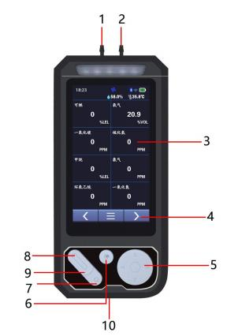

order number | name | order number | name
1 | air intake | 6 | Emergency call button
2 | air-vent | 7 | Cancel key
3 | display screen | 8 | / power switch
4 | Touch the button | 9 | Confirm key
5 | directiion key | 10 | Charging port

3.2 OT139 Gas Detector Display Interface Description
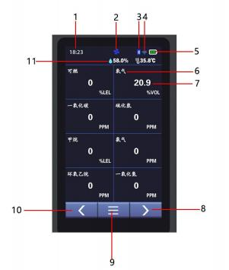

order number | name | order number | name
1 | time display | 6 | Gas name
2 | Pump switch | 7 | Gas number
3 | PDA | 8 | right-hand button
4 | Wifi | 9 | menu
5 | Remaining battery | 10 | Left button
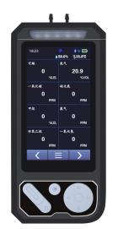

IV. Operating Instructions
4.1 OT139 Portable Multi-Gas Detector Display Interface Description
When the device is powered off, press the power button for more than 3 seconds. After the device vibrates as an indication, power it on. The system will then automatically execute a self-check procedure and enter the main interface, as shown in the following figure:

4.2 Shutdown Instructions for OT139 Portable Multi-Gas Detector
When the device is powered on, tap the menu button on the screen to access the menu interface. Tap the power-off icon and enter the password "1111".

Click OK to shut down the device. As shown below:
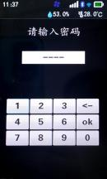
4.3 OT139 Portable Multi-Gas Detector Quick Operation Manual
On the main interface, click the "<" button to enter the shortcut operation interface. Click the air pump button to activate the air pump and begin testing. As shown in the figure below:
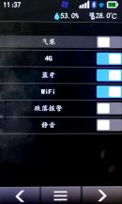

4.4 OT139 Portable Multi-Gas Detector Parameter Functions
See the table below for user menu function descriptions:
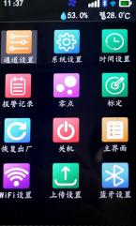
Channel settings: You can configure parameters such as alarm thresholds and ranges for each channel.
System settings: You can configure system operation parameters
Time settings: You can set the instrument time
Alarm records: You can view the alarm records on the instrument.
Zero point: You can set the zero point value for each channel
Calibration: The instrument can be calibrated.
Restore factory settings: You can reset the instrument to factory defaults.
Power off: The instrument can be powered off

Home screen: You can return to the home screen
Upload settings: You can upload cloud platform settings

Warning: Do not charge portable combustible gas detectors at the detection site to avoid fires or explosions caused by sparks from unplugging the charger. Avoid charging portable gas detectors while powered on to prevent reduced charging speed and battery lifespan.

4.5 Operating Instructions

1. Channel settings
a) Go to the menu, click the "Channel Settings" icon to access the channel settings menu. As shown in the figure
b) Click the "Channel Selection" dropdown menu, then select the channel you want to configure, as shown in Figure 1-1
c) Click the parameter to modify. After making changes, click the Save button to save the current settings; alternatively, click

Click the Back button to cancel the settings. See Figure 1-2
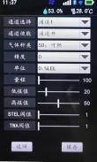
graph 1-1

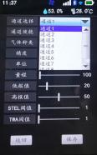
graph 1-2

2. Time settings
a) Go to the menu, click the "Time Settings" icon to access the time settings menu, as shown in Figure 2-1
b) Click the dropdown menu for parameter modification, then select the value to be adjusted as shown in Figure 2-2
c) After making changes, click the Save button to save the current parameters, or click the Back button to cancel the settings.

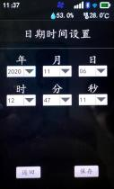
graph 2-1

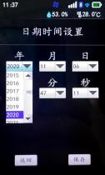
graph 2-2

3. Police report records
a) Enter the menu, click the "Alarm Records" icon to access the Alarm Records View menu, as shown in Figure 3
b) Click the "<" or ">" buttons to navigate pages, and press the "Three" button to return to the menu interface.
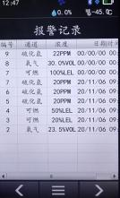
graph 3-1

4. Zero Point Setting
a) Go to the menu, click the "Zero Point" icon, enter the password "1111", and access the Zero Point Translation menu as shown in Figure 4-1
b) Click the "<" or ">" buttons to navigate pages, and press the "Three" button to return to the menu interface.
c) After the zero point value stabilizes, click the "Save" button to save the current zero point value. (Note: The zero point value should be saved in clean air.)

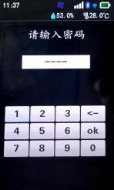
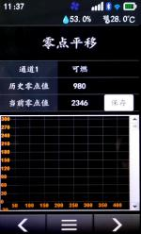

Figure 4-1 Figure 4-2 Figure 4-1 Figure 4-2

5. Calibration
a) Enter the menu, click the "Calibration" icon, input the password "9119" to access the calibration menu, as shown in Figure 5-1
b) Click the "<" or ">" buttons to navigate pages, and press the "Three" button to return to the menu interface;
c) Click "+" and "-" to set the standard gas concentration values for gas flow;
d) Set the flow rate of the standard gas to 1 L/min, wait for the AD value to stabilize, then click the "Save" button to complete the calibration.

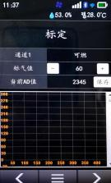
Figure 5-1 Figure 5-2 Figure 5-1 Figure 5-2

6. Restore factory settings
Go to the menu, click the "Restore Factory Settings" icon, and enter the password "5656" to complete the restoration.


7. Upload settings
a) Go to the menu, click the "Upload Settings" icon to access the upload settings menu, as shown in Figure 6
b) Scan the QR code on the Zhihui Cloud mobile app or PC to add this device
c) Click the "Three" button to return to the menu interface

V. Precautions
(1) Prevent the device from falling from a height or experiencing severe vibration.
(2) The device may not function properly in the presence of high-concentration gases.
(3) Please strictly follow the instructions for operation and use; otherwise, it may lead to inaccurate test results or damage to the device.
(4) This product shall not be stored or used in environments containing corrosive gases (such as high concentrations of chlorine gas), nor shall it be used or stored under other harsh conditions (including extreme temperatures, high humidity, electromagnetic fields, or intense sunlight).
(5) If the surface of this device becomes contaminated after prolonged use, gently wipe it with a clean soft cloth dipped in water. Avoid using corrosive solvents or hard objects for cleaning, as this may cause scratches or damage to the device surface.
(6) To ensure detection accuracy, this instrument shall undergo periodic calibration, with the verification cycle not exceeding one year.
(7) It is recommended that the service life of infrared sensors and semiconductor sensors be 5 years, while that of catalytic combustion sensors and electrochemical sensors be 2 years.
(8) Please remove the lithium battery and sensors from the discarded detector and deliver them to the designated location or return them to our company. Do not dispose of them indiscriminately in trash bins.
(9) For any applications or usage issues beyond those described in this manual, please contact our company for assistance.
(10) Battery packs must not be disassembled or replaced, nor charged in explosive gas environments. Peripheral plug-in devices without explosion-proof certification must not be used, and sensors must not be replaced in such environments.

(11) Products with explosion-proof certification shall not be arbitrarily replaced or modified with components or structures that affect their explosion-proof performance.
(12) Relevant national standards contain explicit regulations on the selection, installation, or use of electrical equipment in explosion-hazardous environments. Installation or user entities must strictly comply with these provisions to ensure explosion-proof safety of electrical equipment in such hazardous areas.
(13) Charging must be performed in a safe location and using the professional charger provided with this device.

VI. Common Faults and Their Solutions

fault phenomenon | Possible cause of failure | process mode
Cannot boot | voltage below level | Charge your device promptly
Cannot boot | system halted | Contact the dealer or manufacturer for repair
Cannot boot | fault | Contact the dealer or manufacturer for repair
No reaction to the detected gas | fault | Contact the dealer or manufacturer for repair
Display is inaccurate | Sensor expired | Contact the dealer or manufacturer to replace the sensor.
Display is inaccurate | Long-term uncalibrated | Calibrate promptly
Time display error | The battery is completely drained | Charge promptly and reset the time
Time display error | strong electromagnetic interference | Reset time
Zero calibration is unavailable | Excessive sensor drift | Calibrate or replace the sensor promptly
The instrument's normal detection interface display is inaccurate. | Sensor drift | Perform zero calibration
When the instrument displays full range on the normal detection interface | Sensor failure | Contact the dealer or manufacturer to replace the sensor.

VII. Storage
Portable gas detection and alarm devices should be stored in a ventilated room with an ambient temperature ranging from-20°C to 60°C and relative humidity not exceeding 93%, and the air must be free from harmful gases or impurities that could corrode the devices.

VIII. Accessories
The accompanying portable gas detection alarm includes one portable gas detection alarm, one charger, one instruction manual, and one warranty card with certificate of conformity.

Henan Otywell Electronic Technology Co., Ltd.
Address: Unit 2, Building 38, Lian Dong U Valley, intersection of Jianyang Road and Lianhua Street, High-tech Zone, Zhengzhou City, Henan Province
Hotline: 400-811-8873
Website: http://www.otywell.com

